FamilyCompositionServiceV2: Technical Service Specifications

Historique des révisions
Version | Date | Description | Auteur(s)
2.0 |  | Version initiale pour « V2 » | BCSS
2.1 | 30/03/2018 | Enlève « businessAnomalies » | BCSS
2.2 | 03/04/2018 | Remarques des partenaires | BCSS
2.3 | 30/05/2018 | Ajout « anomalies » hors du résultat | BCSS
2.4 | 24/10/2018 | Ajouter exemples | BCSS
2.5 | 14/11/2018 | Ajouter adresse de référence | BCSS
2.6 | 13/03/2019 | Correction codes retour (nouveaux codes) dans l’annexe sur la construction de la composition « by Ssin » | BCSS
2.7 | 14/03/2019 | Ajouter nouveaux codes position depuis 3/08/2017 | BCSS
2.8 | 23/06/2020 | Ajouter enrichHouseholderWithCurrentAddress flag | BCSS
2.9 | 12/05/2021 | Ajouter code position 24 « coparente » | BCSS
2.10 | 27/09/2021 | Référencer listes de codes au TSS « concepts » | BCSS
2.11 | 25/01/2021 | Corriger images de quelques schémas XML | BCSS
3.0 | 29/11/2022 | Best address :  - suppression des champs « streetRegionalCodeId » et « cityRegionalCodeId » pour les adresses résidentielles et de contact. | BCSS
Participants :

Documents connexes
Document | Auteur(s)
- PID Register webservices: gezinssamenstelling | BCSS
Documentation disponible sur https://www.ksz-bcss.fgov.be  Rubrique : Services et support / Méthode de travail / Architecture orientée service | BCSS
- Documentation générale relative aux définitions des messages de la BCSS  Définitions de messages des services BCSS | BCSS
- Description de l'architecture orientée service de la BCSS  Documentation relative à l'architecture orientée service | BCSS
- Liste des actions pour accéder à la plate-forme des services web de la BCSS et pour tester la connexion.  Accès à l'infrastructure SOA de la BCSS | BCSS
- Registres: concepts et règles | BCSS
- TSS Registries annex: return codes | BCSS

Distribution
Révision | Destinataire(s) | Date
1.0

Table des matières
1 Objectif du document 4
2 Acronymes 4
3 Aperçu du service 4
3.1 Contexte 4
3.2 Déroulement général 5
3.3 Etapes de traitement à la BCSS 10
4 Protocole du service 12
5 Description des messages échangés 13
5.1 Partie commune aux opérations 13
5.2 searchFamilyCompositionBySsin 29
5.3 searchFamilyCompositionHistoryBySsin 31
5.4 searchFamilyCompositionBySsinAndDate 32
5.5 searchHouseholderBySsin 34
5.6 searchHouseholderHistoryBySsin 36
5.7 searchHouseholderBySsinAndDate 37
5.8 Fault 38
6 Codes du statut des réponses BCSS 38
7 Listes de codes 38
8 Disponibilité et performance 38
8.1 En cas de problèmes 38
9 Best practices 39
9.1 Validation à l’aide d’un WSDL/XSD 39
9.2 Format des dates 39
10 Messages d’exemple 39
10.1 searchFamilyCompositionBySsin 39
10.2 searchFamilyCompositionHistoryBySsin 42
10.3 searchFamilyCompositionBySsinAndDate 46
10.4 searchHouseholderBySsin 48
10.5 searchHouseholderHistoryBySsin 50
10.6 searchHouseholderBySsinAndDate 53
11 Annexes 55
11.1 Construction of the family composition 55
11.2 FAQ 66

Objectif du document
Ce document décrit les spécifications techniques du Web Service FamilyCompositionServiceV2 de la plateforme SOA de la BCSS.
Il décrit le contexte, les modalités d’utilisation, les fonctionnalités et les opérations (requêtes et réponses) du service. Pour chaque type de message, des exemples sont ajoutés. La fin du document contient une liste de codes erreurs susceptibles d’être retournés.
Avec ce document le service informatique du client doit être capable d’intégrer et d’utiliser correctement le Web Service de la BCSS.

Acronymes
- BCSS : Banque Carrefour de la Sécurité Sociale
- CTMS : CodeTable Management System de la BCSS
- NISS : Numéro d’Identification à la Sécurité Sociale
- RN : Registre National

Aperçu du service

Contexte
L’objectif de ce service est la consultation des compositions de ménage des personnes enregistrées dans les bases de données du registre national et de la BCSS. La personne pour laquelle on demande la composition de ménage, ne doit pas nécessairement être chef du ménage. Ce service propose 4 fonctionnalités distinctes, la disponibilité de ces opérations en fonction de la source authentique de la personne traitée, étant :
Opération | BCSS BIS | BCSS RAD | BCSS RAN | Registre national
SearchFamilyCompositionBySsin | N/A | N/A | N/A2 | oui
SearchFamilyCompositionBySsinAndDate | N/A1 | oui1 | oui1 | oui
searchHistoryBySsin | N/A1 | oui1 | oui1 | oui

Diagramme de contexte

BCSS
Partenaire

Partenaire

Partenaire

RN
BIS
RAD
Cellule d’identification BCSS
RAN
- La BCSS : chargée de délivrer aux partenaires les compositions de ménages et de gérer les données d’identification de registres BIS/RAD.
- Le Registre national : fournisseur de données relatives aux compositions de ménage et gestionnaire des données d’identification pour les personnes dont la source authentique est le registre national.
- Les partenaires : intéressés par les compositions de ménage.

Déroulement général

searchFamilyCompositionBySsin
Fonctionnalité : consulter le contenu d’une composition de ménage sur base d’un numéro NISS.
D’abord, le chef de ménage actuel est retrouvé pour le NISS donnée, puis pour ce chef de ménage tous les membres de famille actuels sont recherchés.

Diagramme d’activité
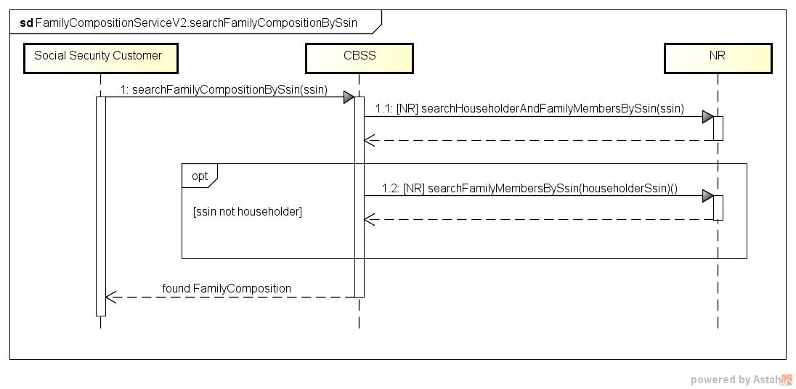

searchFamilyCompositionHistoryBySsin
Fonctionnalité : consulter le contenu de l’historique d’une composition de ménage sur base d’un numéro NISS.
D’abord, tous les chefs de ménage sont retrouvés pour le NISS donnée, puis pour chaque chef de ménage tous les membres de famille sont recherchés. Seuls les membres ayant un chevauchement en période avec le NISS demandé sont retournés.

Diagramme d’activité
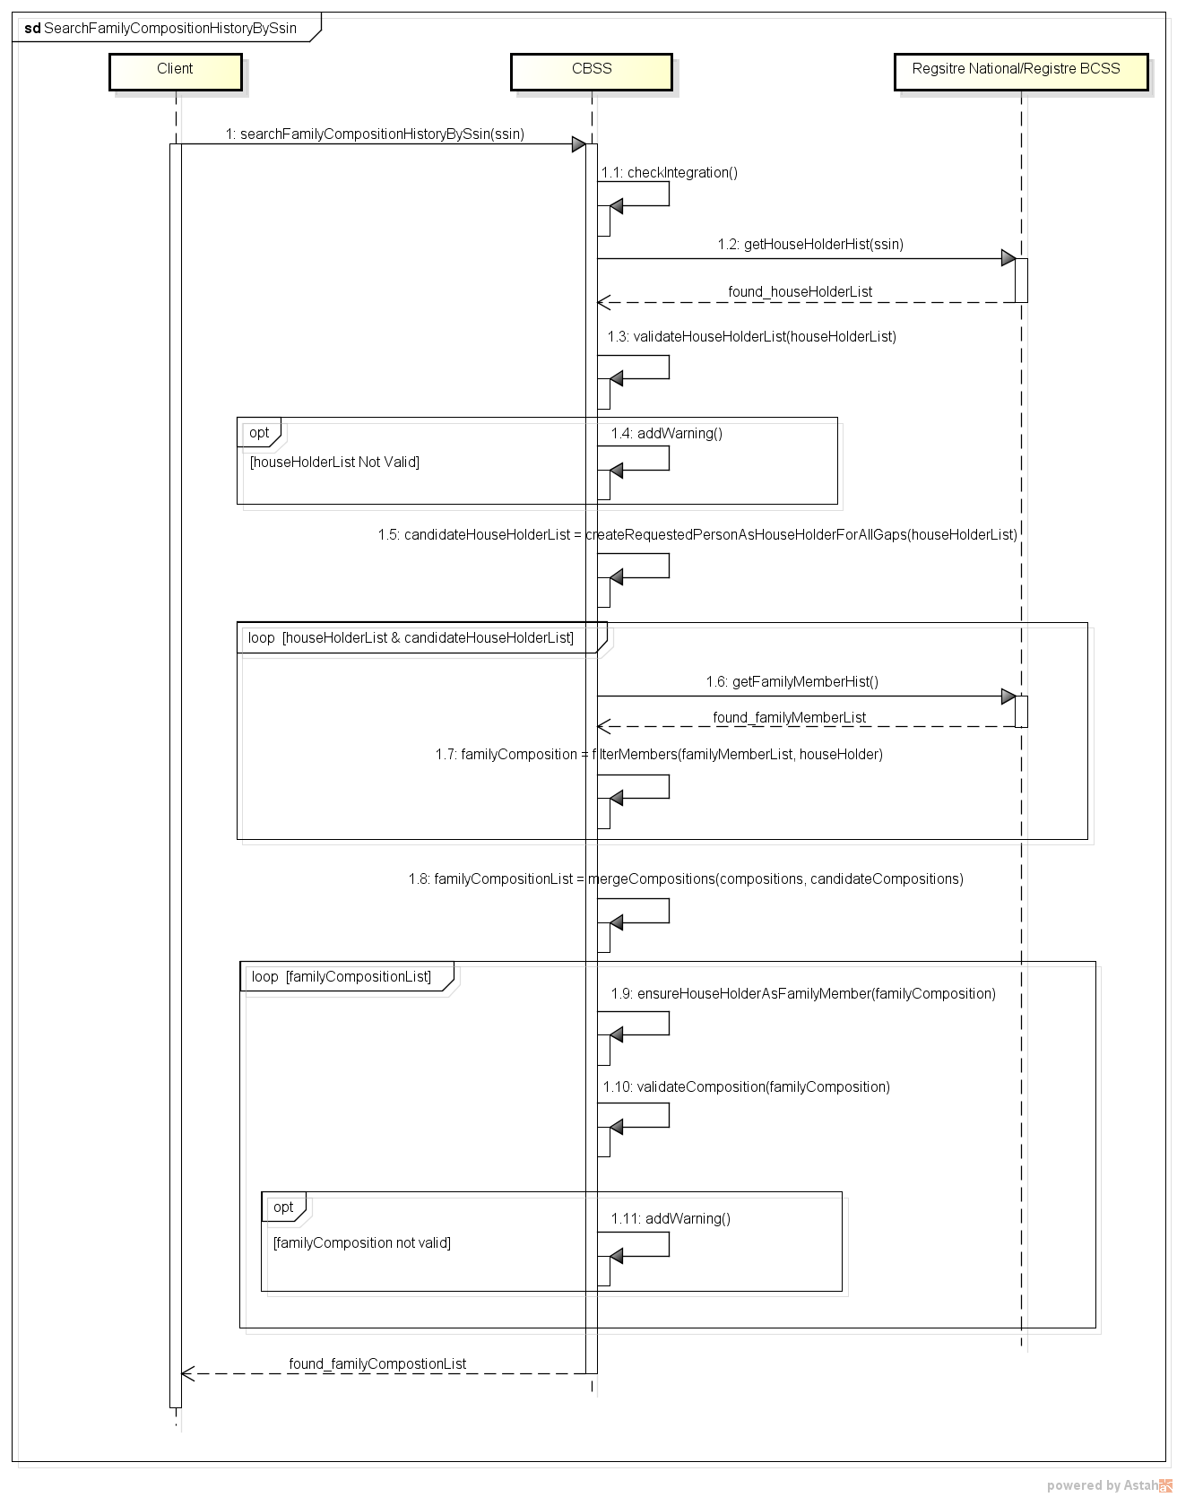

searchFamilyCompositionBySsinAndDate
Fonctionnalité : consulter le contenu d’une composition de ménage sur base d’un numéro NISS et pour une date de référence donnée.
D’abord, tous les chefs de ménage sont retrouvés pour le NISS donnée, puis pour celui qui était le chef de ménage à la date demandée, tous les membres de famille sont recherchés. Seuls les membres ayant un chevauchement en période avec le NISS demandé sont retournés.
L’utilisation de l’opération searchFamilyCompositionBySsinAndDate est strictement reservée à une consultation de données dans le passé. Cette opération implique la demande et le traitement de données historiques, ce qui est complétement inutile dans l’obtention d’une situation actuelle. En cas d’incohérences dans les données du Registre National, la consultation de la situation actuelle est plus fiable. Pour une consultation de données actuelles il faut utiliser l’opération searchFamilyCompositionBySsin.

Diagramme d’activité
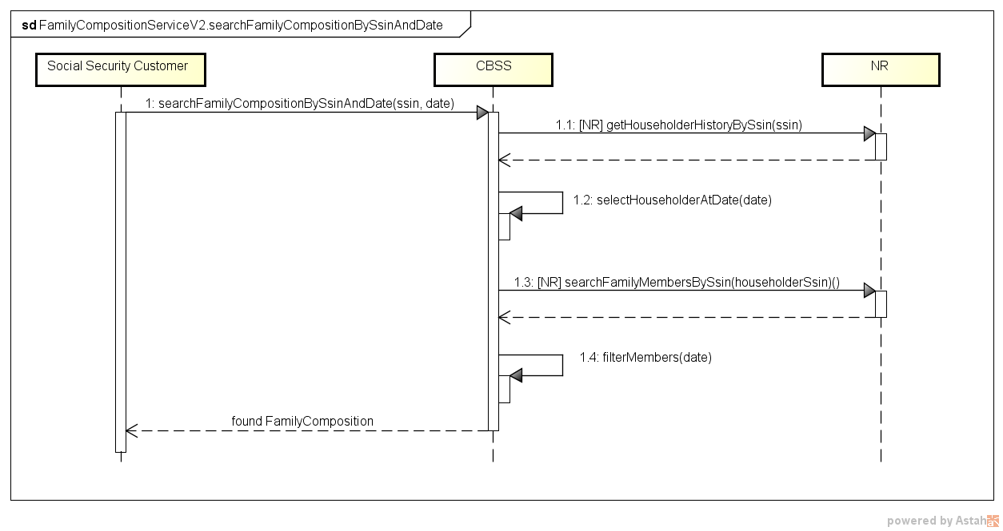

searchHouseholderBySsin

Diagramme d’activité
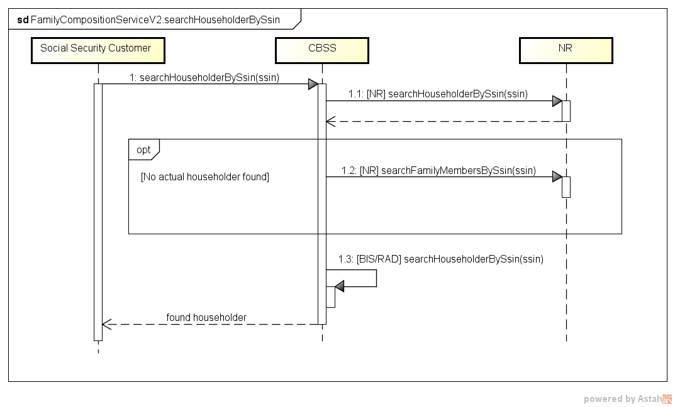

searchHouseholderHistoryBySsin

Diagramme d’activité
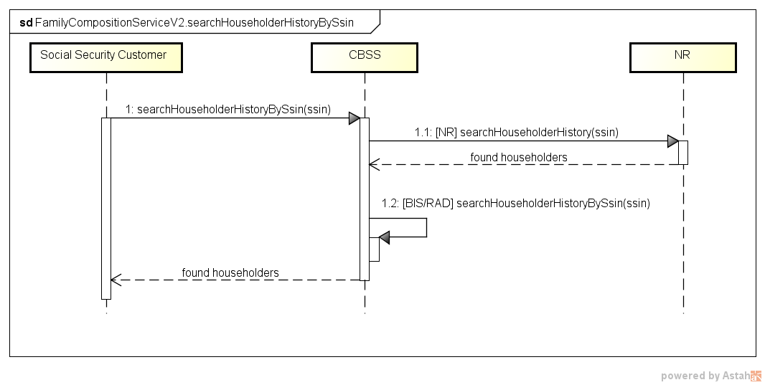

searchHouseholderBySsinAndDate

Diagramme d’activité
Voir §3.3.5.1

Etapes de traitement à la BCSS
- Contrôle de l’intégrité des messages (validation XSD)
- Logging de sécurité
- Validation des critères de recherche
- Contrôle du NISS
- Contrôle d’intégration
- Filtrage
- Composition du résultat

Contrôle de l’intégrité des messages
Il s’agit d’une validation classique du message XML vis à vis du schéma. C’est donc une validation des contraintes de typage sur les données et sur leur structure.

Logging de sécurité
Pour des raisons légales, la BCSS fera du logging des messages entrants et sortants afin que des audits de sécurité soient possible.

Validation des critères de recherche
Pour les recherches sur date, on valide si la date demandé est dans le passé.

Contrôle du NISS
Un NISS est soit valide, soit invalide.
- S’il est invalide (problème de syntaxe et/ou de checksum), le message est rejeté par la BCSS, et un message d’erreur est renvoyé au client lui indiquant que le NISS utilisé est un NISS invalide.
- S’il est valide, il faudra déterminer s’il fait partie d’une catégorie spéciale. Si ce n’est pas le cas, alors le traitement du message peut continuer.
Catégories spéciales :
  - NISS inconnu : le NISS est inconnu tant du Registre national que du Registre BCSS. Dans ce cas, le message est rejeté, et un message d’erreur est renvoyé au client lui indiquant que le NISS utilisé est un NISS inconnu.
  - NISS annulé : le NISS a été annulé par le RN. Dans ce cas, le traitement ne continuera pas et le client recevra dans la réponse, une indication concernant l’annulation du NISS.
  - NISS remplacé : le traitement continuera avec le nouveau NISS et le client recevra dans la réponse une indication concernant le remplacement du NISS. Dans la réponse, il recevra aussi le nouveau NISS et bien évidemment le résultat du traitement.
Il faut noter qu’il est possible qu’un NISS ne soit pas encore remplacé auprès du fournisseur alors qu’il l’est déjà au niveau de la source authentique. Dans ce cas, le client est invité à refaire sa requête dans les jours qui suivent afin que le remplacement ait le temps de se propager au sein du réseau.

Contrôle d’intégration
Comme la consultation concerne des personnes et que l’identification de ces dernières se fait via leur NISS, la BCSS réalisera un contrôle d’intégration. Ce contrôle d’intégration poursuivra deux objectifs :
- Vérifier que le partenaire connait la personne et peut donc consulter les données demandées.
- Vérifier que le fournisseur de données connait la personne. Cela évitera d’interroger le fournisseur pour des personnes qui lui sont inconnues.

Filtrage
Seulement les données personnels autorisés sont retournées.

Composition du résultat
Le détail de la composition du résultat est décrit dans §9.1.

Calcul des périodes
- Pour chaque membre de famille, on prend la période du TI 140 de son chef de ménage
- Si la personne demandée est chef de ménage, on calcule la période sur base de ses membres de famille dans le TI 140
Les périodes des chefs de ménage de la personne demandée ne sont pas disponibles, mais elles ne sont pas relevantes. Ce qui compte pour la personne demandée, c’est la période où elle était dans la famille

Calcul des périodes : exemple
NISS A
- TI 140
  - B 2 (conjoint) 2008 – …
  - E 3 (fils/fille) 2009 – …
  - E 3 (fils/fille) 2011 – 2015
  - B 12 (non-apparenté(e)) 2006 – 2008
  - A 1 (célibataire) 2005 – 2006
- TI 141
  - P 3 (fils/fille) 1982 – 2006
NISS P
- TI 140
  - X 3 (fils/fille) 2014 – …
  - S 2 (conjoint) 2012 – …
  - M 2 (conjoint) 1980 – 2010
  - A 3 (fils/fille) 1982 – 2006
  - F 3 (fils/fille) 1980 – 2002
Résultat :
- familyComposition
  - familyMember: A 1 (chef de ménage) 2006 – …
  - familyMember: B 2 (conjoint) 2008 – …
  - familyMember: E 3 (fils/fille) 2009 – …
  - familyMember: E 3 (fils/fille) 2011 – 2015
  - familyMember: B 12 (non-apparenté(e)) 2006 – 2008
- familyComposition
  - familyMember: A 1 (chef de ménage) 2005 – 2006
- familyComposition
  - familyMember: P 1 (chef de ménage) /
  - familyMember: M 2 (conjoint) 1980 – 2010
  - familyMember: A 3 (fils/fille) 1982 – 2006
  - familyMember: F 3 (fils/fille) 1980 – 2002
Pour d’amples informations sur le calcul des périodes, voir annexe.

Protocole du service
La communication aura lieu dans un environnement sécurisé au moyen de messages SOAP. Pour plus d'informations sur l'architecture orientée service, veuillez-vous référer au [3]. Si un partenaire n'a pas encore accès à l'infrastructure SOA de la BCSS, une liste des démarches à réaliser pour obtenir un accès et tester cet accès est disponible sur [4].
Protocole applicatif | HTTPS 2ways TLS, SOAP 1.1
Nom du service | FamilyCompositionService
WSDL du service | FamilyCompositionServiceV2.wsdl  http://kszbcss.fgov.be/intf/registries/FamilyCompositionService/v2/consult
Opérations | searchFamilyCompositionBySsin  searchFamilyCompositionHistoryBySsin  searchFamilyCompositionBySsinAndDate  searchHouseholderBySsin  searchHouseholderHistoryBySsin  searchHouseholderBySsinAndDate
Messages | searchFamilyCompositionBySsinRequest  searchFamilyCompositionBySsinResponse  searchFamilyCompositionBySsinFault  searchFamilyCompositionHistoryBySsinRequest  searchFamilyCompositionHistoryBySsinResponse  searchFamilyCompositionHistoryBySsinFault  searchFamilyCompositionBySsinAndDateRequest  searchFamilyCompositionBySsinAndDateResponse  searchFamilyCompositionBySsinAndDateFault  searchHouseholderBySsinRequest  searchHouseholderBySsinResponse  searchHouseholderBySsinFault  searchHouseholderHistoryBySsinRequest  searchHouseholderHistoryBySsinResponse  searchHouseholderHistoryBySsinFault  searchHouseholderBySsinAndDateRequest  searchHouseholderBySsinAndDateResponse  searchHouseholderBySsinAndDateFault
Environnement, host et port | Dev | b2b-test.ksz-bcss.fgov.be:4520
 | Acc | b2b-acpt.ksz-bcss.fgov.be:4520
 | Prod | b2b.ksz-bcss.fgov.be:4520
URI | /FamilyCompositionService/v2/consult

Description des messages échangés

Partie commune aux opérations

Identification du client [informationCustomer]
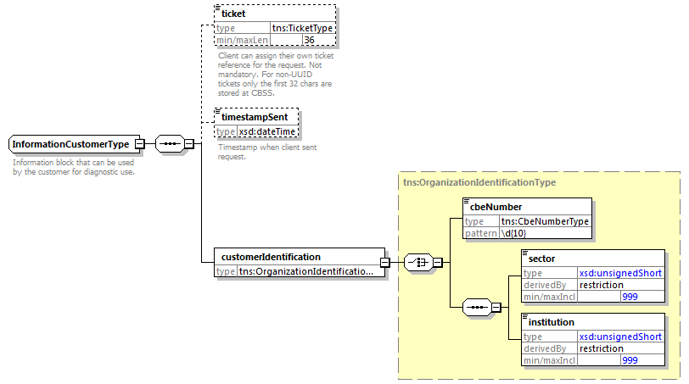
L’élément informationCustomer est fourni par le client en vue de s’identifier au niveau métier en fournissant son identification soit au niveau du réseau de la sécurité sociale, soit au niveau entreprise. Il peut contenir des références temporelles et métier.
L’identification de l’institution est définie dans un message:
- soit à l’aide de la combinaison secteur/institution pour les institutions au sein de la sécurité sociale
- soit à l’aide du numéro BCE pour les institutions ne faisant pas partie de la sécurité sociale ou encore pour les institutions pour lesquelles ce numéro BCE offre une valeur ajoutée en plus de l'utilisation du secteur/de l’institution

Identification de la BCSS [informationCBSS]
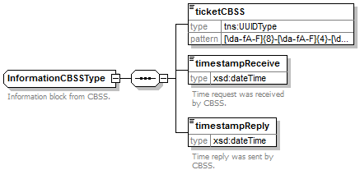
L’élément informationCBSS, facultatif en requête, est complété par la BCSS et dispose de diverses informations nécessaires au logging et au support.

Contexte légal de l’appel [legalContext]
L’élément legalContext permet de définir dans quel cadre légal est émise la requête.

Statut de la réponse [status]
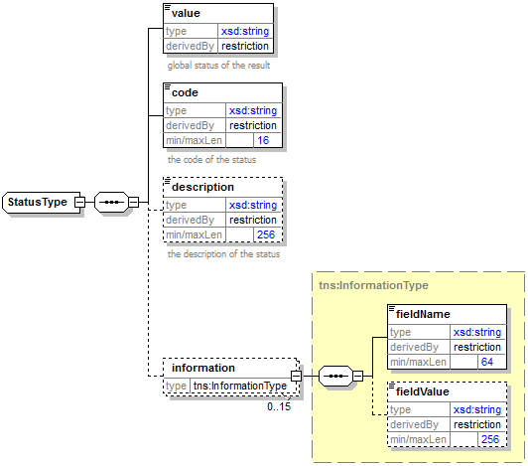
L’élément status est présent dans chaque réponse de la BCSS et représente le statut global du traitement de la requête. Il est constitué des éléments :
- value : énumération donnant une indication générale sur le statut de la réponse. 3 valeurs sont possibles :
Valeur | Description
DATA_FOUND | Traitement réussi.
NO_DATA_FOUND | Traitement réussi mais pas de données trouvées.
NO_RESULT | Le traitement ne s’est pas déroulé avec succès. Aucune information n’a pu être reçue.

- code : plus précis que l’élément value, ce champ contient un code business propre au service.
- description : cet élément donne une explication sur la signification du champ code
- information : cet élément est rempli dans le cas où davantage d’informations doivent être ajoutées dans le statut afin d’avoir une explication complémentaire

NISS avec status [ssin] ‘annulé’ ou ‘remplace’
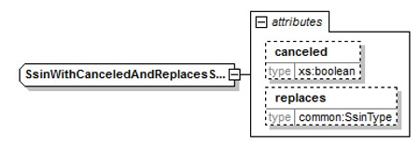
L’élément ssin est présent dans la réponse de la BCSS et retourne le NISS sur la base duquel la demande a eu lieu ainsi que des informations relatives au statut de ce NISS dans les attributs:
Attribut | Description
canceled | Si cet élément est présent et est égal à ‘true’, le NISS a été annulé et ne peut pas être utilisé.
replaces | Si cet élément est présent, le NISS a été remplacé. Le NISS original est renvoyé dans cet attribut et le nouveau NISS est contenu dans l’élément même.

Composition de ménage [familyComposition]
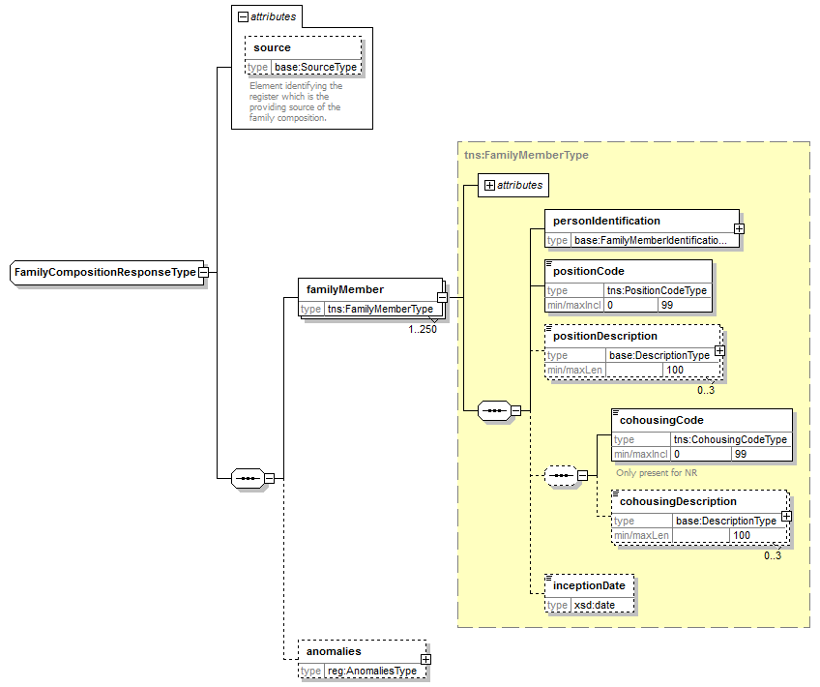
Elément |  | Description
source |  | Source des données. Toujours Registre National.
familyMember |  | Détails d’un membre d’un ménage
 | source | Source des données. Toujours Registre National.
 | personIdentification | Données personnelles du membre du ménage
 | positionCode | La position par rapport au chef de ménage
 | positionDescription | Description du code position
 | cohousingCode | Code relatif à la notion d’habitation collective
 | cohousingDescription | Description du code d’habitation collective
 | inceptionDate | Date de rentrée du membre dans le ménage
anomalies |  | Avertissements sur des inconsistances dans la composition de ménage

Identification d’un membre de famille [FamilyMemberIdentificationType]
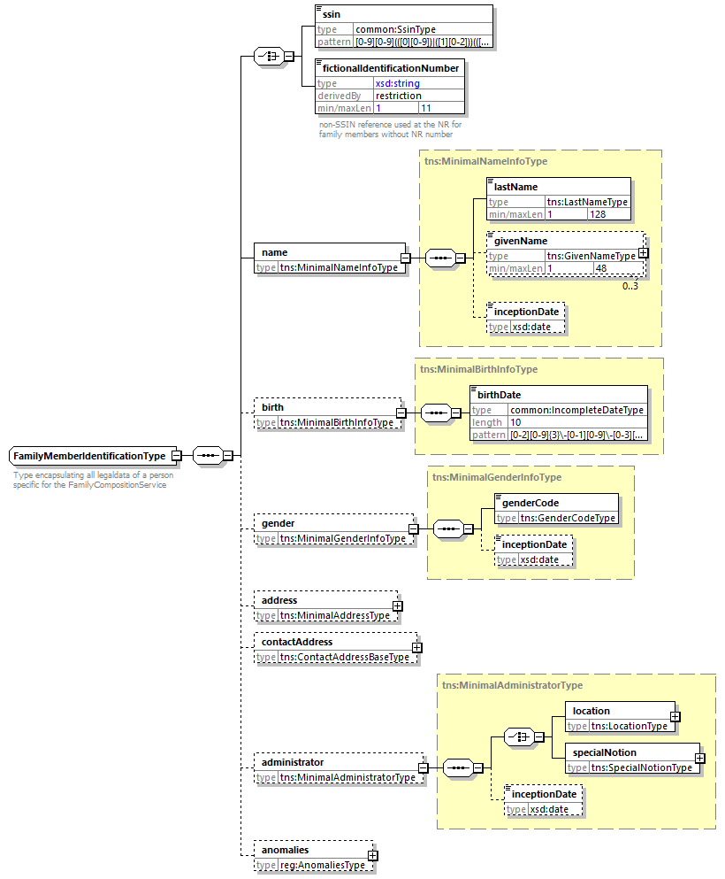

Elément |  | Description
ssin |  | Numéro NISS du membre du ménage
fictionalIdentificationNumber |  | Numéro d’identification fictif, utilisé par le registre national dans le cas d’un membre de ménage sans numéro NISS valide
name |  | Le nom
 | lastName | Nom
 | givenName | 1 à 3 prénoms
 | inceptionDate | Date de prise de cours
birth |  | Informations relatives à la naissance
 | birthDate | Date de naissance
gender |  | Informations relatives au sexe
 | genderCode | Le sexe
 | inceptionDate | Date de prise de cours
address |  | L'adresse de la personne. Seulement présent pour le chef de ménage dans la situation actuelle.
contactAddress |  | Adresse de contact de la personne. Pas présent pour les personnes dans le Registre National.
administrator |  | Informations relatives au gestionnaire des données. Seulement présent pour le chef de ménage dans la situation actuelle.
 | location | Gestionnaire des données (commune ou pays)
 | specialNotion | Code INS spéciale. En principe ce n’est pas possible pour un chef de ménage
 | inceptionDate | Date de prise de cours
anomalies |  | Inconsistances dans les données personnelles

Adresse [address]
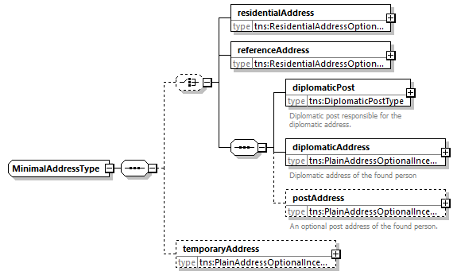
Element | Beschrijving
residentialAddress | Adresse de résidence en Belgique
referenceAddress | Adresse de référence en Belgique
diplomaticPost | Ne sera pas présent
diplomaticAddress | Ne sera pas présent
postAddress | Ne sera pas présent
temporaryAddress | Ne sera pas présent

Adresse de résidence [residentialAddress]

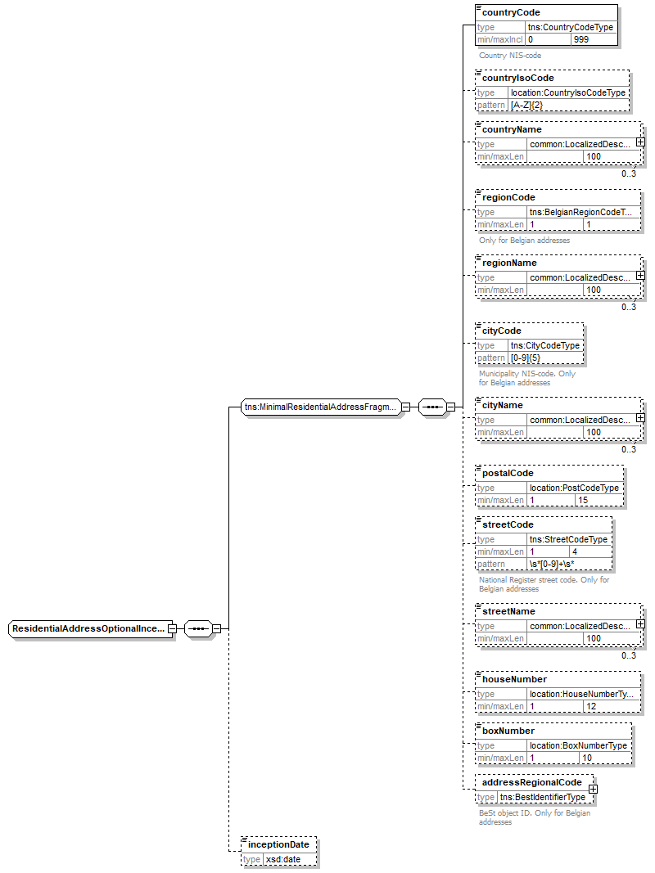
Les champs possibles sont différents pour une adresse belge et une adresse étrangère. Pour une adresse belge, tous les champs peuvent être remplis. En ce qui concerne une adresse à l’étranger, les champs applicables sont marqués dans la colonne « Etranger ».
Élément | Description | Etranger | Belge « vieux » | Belge « BeSt »
countryCode | Le code pays du pays (code INS) | ✓ | 150 | 150
countryIsoCode | Le code ISO du pays sous forme d’un code à 2 lettres (ISO 3166 alpha-2) | ✓ | ✓ | ✓
countryName | Le nom du pays | ✓ | ✓ | ✓
regionCode | Le code région de la région |  |  | ✓
regionName | La dénomination de la région |  |  | ✓
cityCode | Code commune (code INS) |  | ✓ | ✓
cityName | Nom de la commune | ✓ | ✓
postalCode | Code postal de la commune | ✓ | ✓
streetCode | Code de la rue attribué par le Registre national |  | ✓
streetName | Nom de la rue | ✓ | ✓ | ✓
HouseNumber | Numéro de maison | ✓ | ✓ | ✓
boxNumber | Numéro de la boîte | ✓ | ✓ | ✓
addressRegionalCode | Un numéro d'identification unique de l’adresse au sein de la source authentique régionale |  |  | ✓
inceptionDate | Date de prise de cours de la donnée | ✓ | ✓ | ✓

Adresse de référence [referenceAddress]
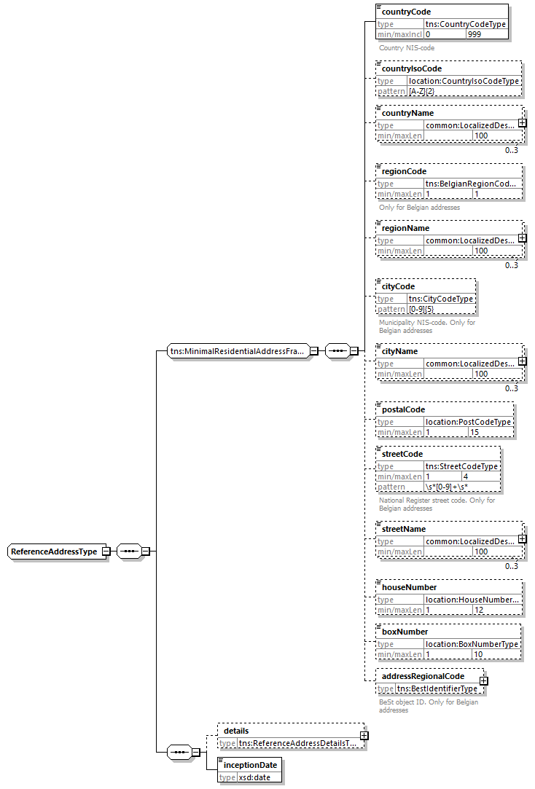
Element | Beschrijving
countryCode | Le code pays du pays (code INS)
countryIsoCode | Le code ISO du pays sous forme d’un code à 2 lettres (ISO 3166 alpha-2)
countryName | Le nom du pays
regionCode | Le code région de la région
regionName | La dénomination de la région
cityCode | Code commune (code INS)
cityName | Nom de la commune
postalCode | Code postal de la commune
streetCode | Code de la rue attribué par le Registre national
streetName | Nom de la rue
houseNumber | Numéro de la maison
boxNumber | Numéro de la boîte
addressRegionalCode | Un numéro d'identification unique de l’adresse au sein de la source authentique régionale
details | Les détails sur l’adresse de référence
inceptionDate | Date de prise de cours de la donnée

Détails de l'adresse de référence [referenceAddressDetails]
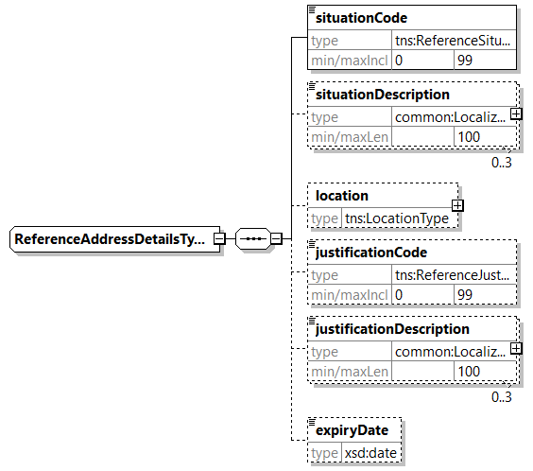
element | beschrijving
situationCode | Code qui correspond à une catégorie/situation dans laquelle se trouve la personne.
situationDescription | Une catégorie/situation dans laquelle se trouve la personne.
location | La municipalité impliquée
justificationCode | Code correspondant à une raison pour laquelle une adresse de référence a été attribuée
justificationDescription | Description de la raison pour laquelle une adresse de référence a été attribuée
expiryDate | La date de fin prévue du statut de l'adresse de référence.

Composition de ménage historique [familyComposition]
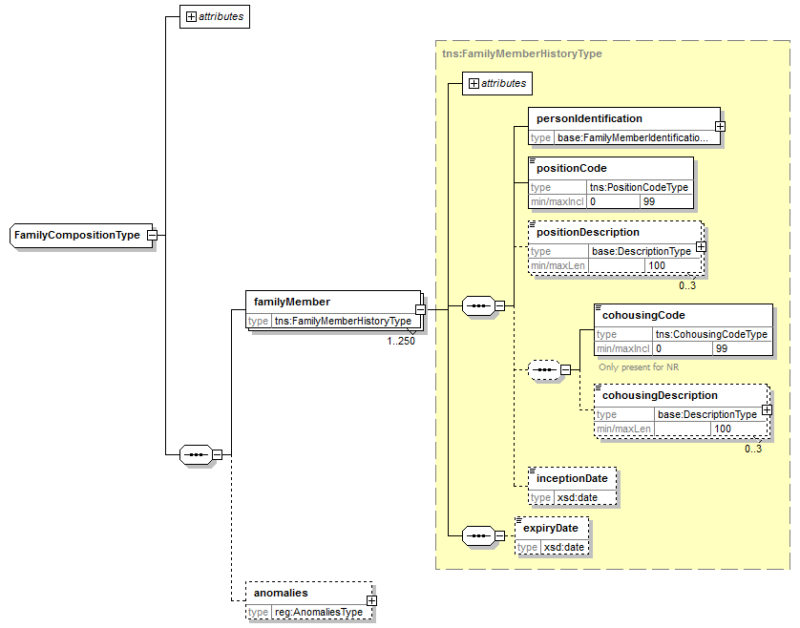
Elément |  | Description
source |  | Source des données. Toujours Registre National.
familyMember |  | Détails d’un membre d’un ménage
 | (Tous les champs) | Voir §5.1.6
 | expiryDate | Date de fin pour le membre dans le ménage
anomalies |  | Avertissements sur des inconsistances dans les données des compositions de ménage

Chef de ménage [householder]
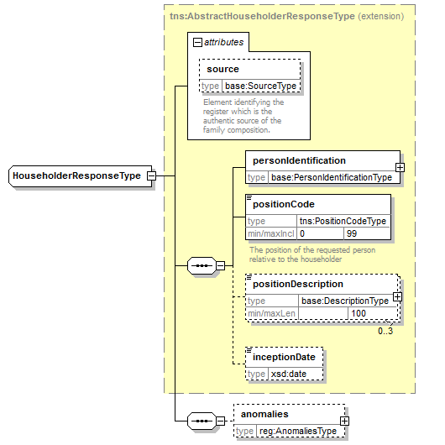
Elément | Description
source | Source des données. Toujours Registre National.
ssin | Numéro NISS du chef de ménage
personIdentification | Données personnelles du chef du ménage
positionCode | La position de la personne concerné par rapport au chef de ménage
positionDescription | Description du code position
inceptionDate | Date de rentrée de la personne dans le ménage du chef
anomalies | Avertissements sur des inconsistances dans les données des chefs de ménage

Chef de ménage historique [householder]
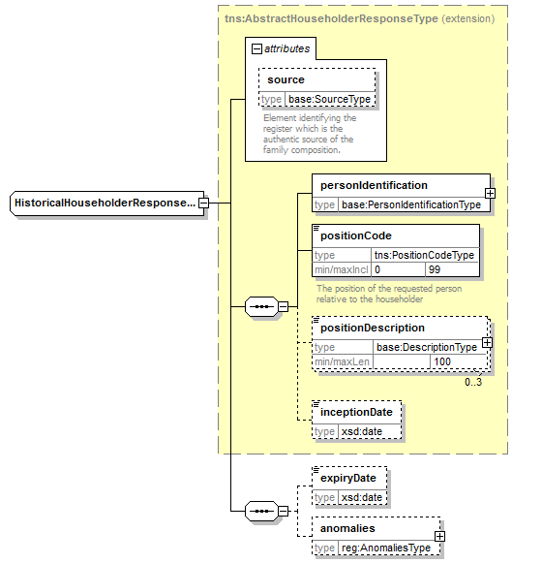
Elément | Description
(Autres champs) | Voir §5.1.8
expiryDate | Date de fin dans la composition du chef de ménage

Identification d’un chef de ménage [PersonIdentificationType]
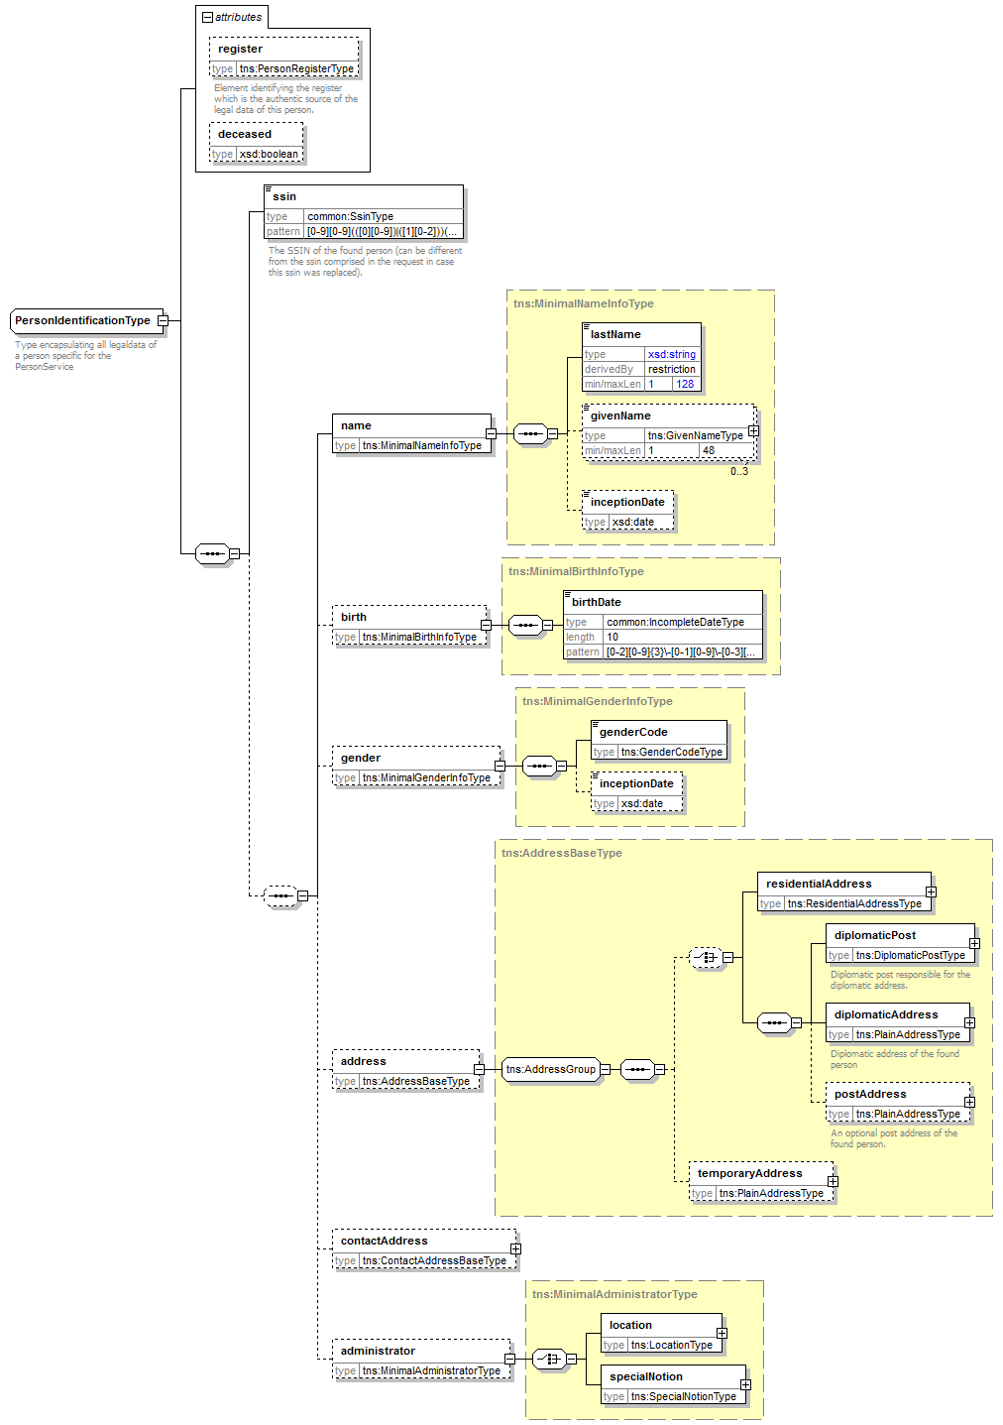
Elément |  | Description
ssin |  | Numéro NISS du chef de ménage
name |  | Le nom
 | lastName | Nom
 | givenName | 1 à 3 prénoms
 | inceptionDate | Date de prise de cours
birth |  | Informations relatives à la naissance
 | birthDate | Date de naissance
gender |  | Informations relatives au sexe
 | genderCode | Le sexe
 | inceptionDate | Date de prise de cours
address |  | Ne sera pas présent
contactAddress |  | Ne sera pas présent
administrator |  | Ne sera pas présent

Anomalies [anomalies]
Voir [6].

searchFamilyCompositionBySsin

Requête
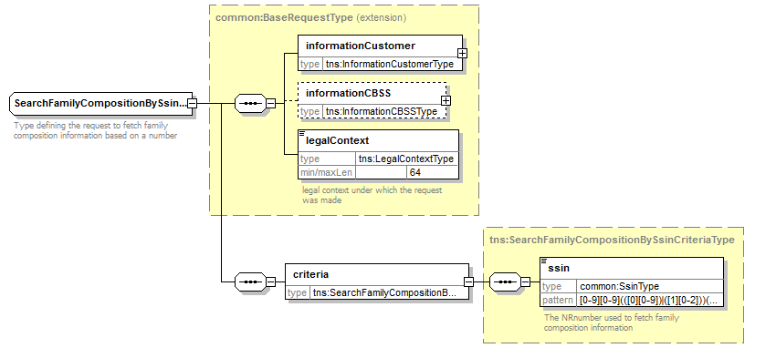

Elément |  | Description
informationCustomer |  | Information sur le demandeur, voir §5.1.1
informationCBSS |  | Ne pas remplir
legalContext |  | Cadre légal, voir §5.1.3
criteria |  | Information spécifique au critère de recherche
 | ssin | Le NISS pour lequel on demande la composition de ménage

Réponse
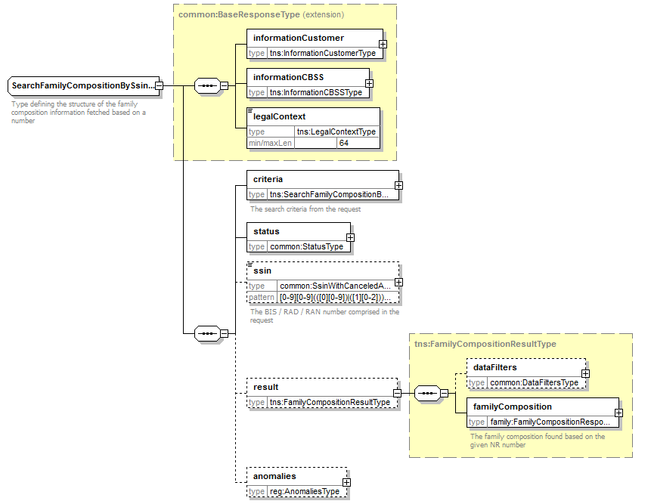

Elément |  | Description
informationCustomer |  | Repris de la requête
informationCBSS |  | Information de la BCSS, voir §5.1.2
legalContext |  | Repris de la requête
criteria |  | Repris de la requête
status |  | Statut de la réponse, voir §5.1.4
ssin |  | Le NISS pour lequel on a répondu, voir §5.1.5
result |  | Le résultat de la recherche
 | dataFilters | Le filtrage des données appliqué
 | familyComposition | La composition de ménage retrouvé, voir §5.1.6
anomalies |  | Avertissements sur des inconsistances qui  - empêchent de construire une composition  - n'appartiennent pas à une composition particulière

searchFamilyCompositionHistoryBySsin

Requête
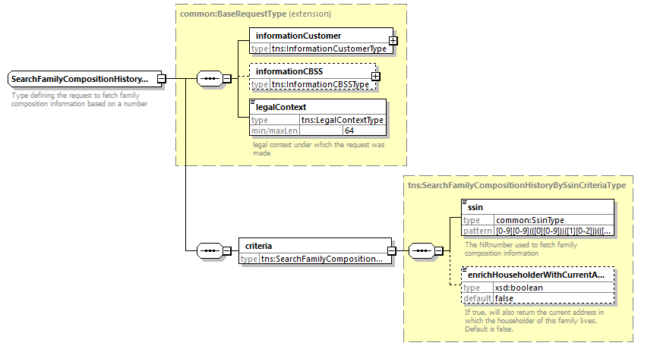
Elément |  | Description
informationCustomer |  | Information sur le demandeur, voir §5.1.1
informationCBSS |  | Ne pas remplir
legalContext |  | Cadre légal, voir §5.1.3
criteria |  | Information spécifique au critère de recherche
 | ssin | Le NISS pour lequel on demande la composition de ménage
 | date | Permet de retrouver la composition de ménage à cette date
 | enrichHouseholderWithCurrentAddress | Flag optionnel, qui permet d’obtenir les adresses actuelles des chef de ménages. En l’absence, aucune adresse ne sera communiquée

Réponse
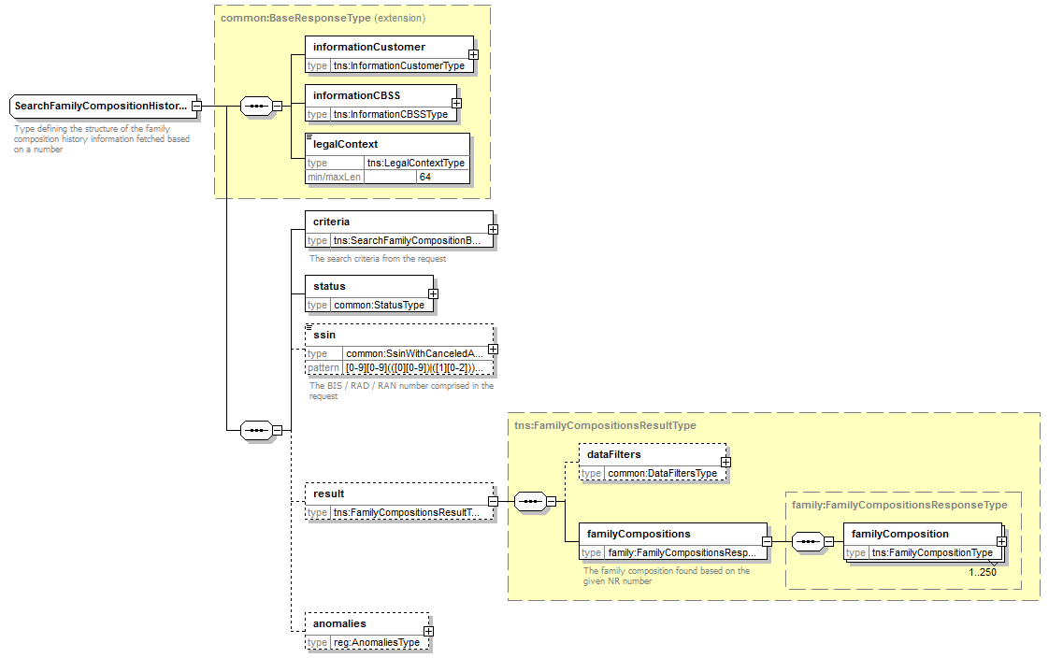

Elément |  |  | Description
informationCustomer |  |  | Repris de la requête
informationCBSS |  |  | Information de la BCSS, voir §5.1.2
legalContext |  |  | Repris de la requête
criteria |  |  | Repris de la requête
status |  |  | Statut de la réponse, voir §5.1.4
ssin |  |  | Le NISS pour lequel on a répondu, voir §5.1.5
result |  |  | Le résultat de la recherche
 | dataFilters |  | Le filtrage des données appliqué
 | familyCompositions |  | Les composition de ménage historiques retrouvés
 |  | familyComposition | Voir §5.1.7
anomalies |  |  | Avertissements sur des inconsistances qui  - empêchent de construire une composition  - n'appartiennent pas à une composition particulière

searchFamilyCompositionBySsinAndDate

Requête

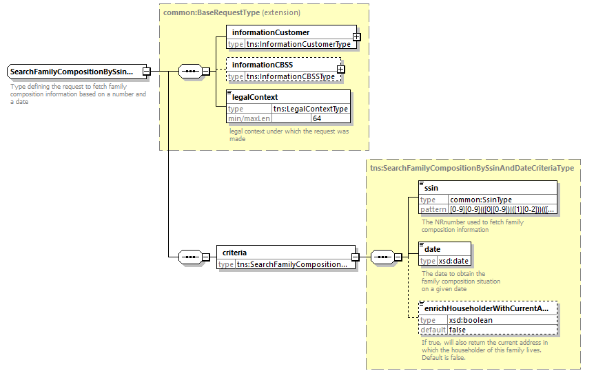
Elément |  | Description
informationCustomer |  | Information sur le demandeur, voir §5.1.1
informationCBSS |  | Ne pas remplir
legalContext |  | Cadre légal, voir §5.1.3
criteria |  | Information spécifique au critère de recherche
 | ssin | Le NISS pour lequel on demande la composition de ménage
 | date | Permet de retrouver la composition de ménage à cette date
 | enrichHouseholderWithCurrentAddress | Flag optionnel, qui permet d’obtenir l’adresse actuelle du chef de ménage. En l’absence, aucune adresse ne sera communiquée

Réponse
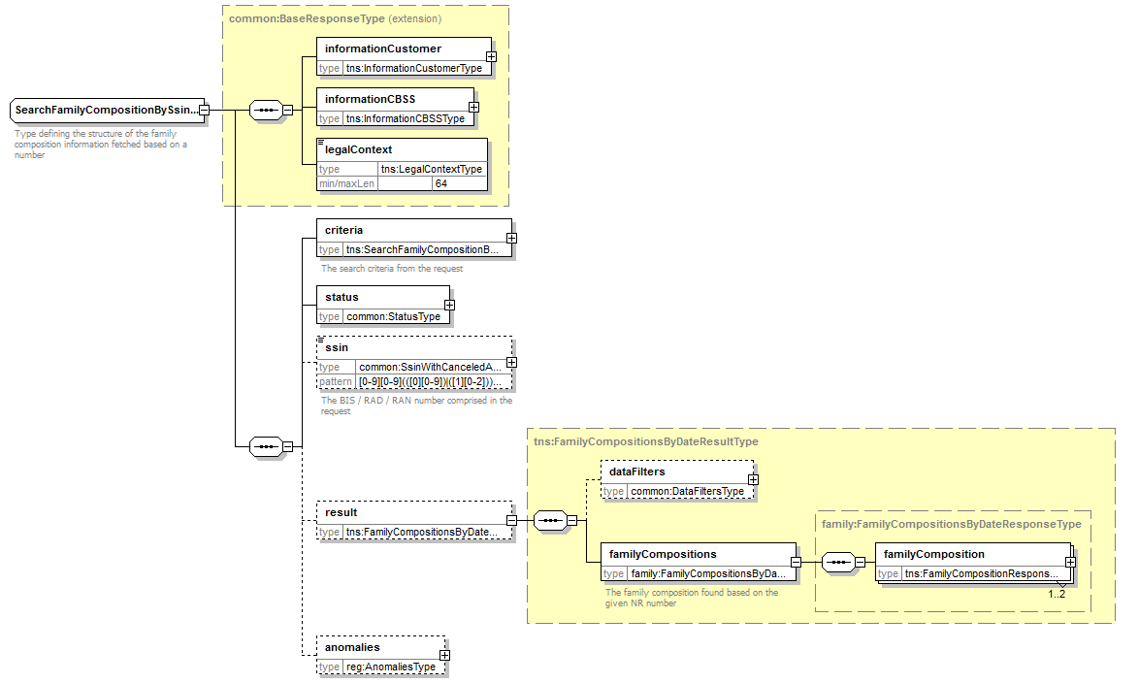

Elément |  |  | Description
informationCustomer |  |  | Repris de la requête
informationCBSS |  |  | Information de la BCSS, voir §5.1.2
legalContext |  |  | Repris de la requête
criteria |  |  | Repris de la requête
status |  |  | Statut de la réponse, voir §5.1.4
ssin |  |  | Le NISS pour lequel on a répondu, voir §5.1.5
result |  |  | Le résultat de la recherche
 | dataFilters |  | Le filtrage des données appliqué
 | familyCompositions |  | Les composition de ménage retrouvés (1, max 2 quand supporté par les registres BCSS)
 |  | familyComposition | Voir §5.1.6
anomalies |  |  | Avertissements sur des inconsistances qui  - empêchent de construire une composition  - n'appartiennent pas à une composition particulière

searchHouseholderBySsin

Requête
Idem à §5.2.1

Réponse
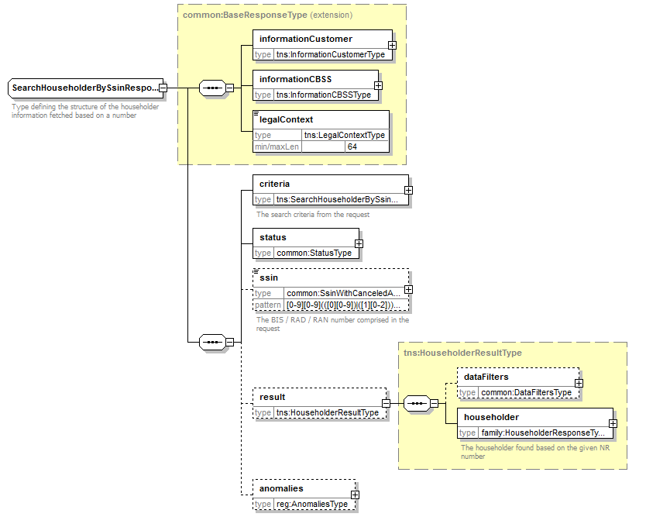
Elément |  | Description
informationCustomer |  | Repris de la requête
informationCBSS |  | Information de la BCSS, voir §5.1.2
legalContext |  | Repris de la requête
criteria |  | Repris de la requête
status |  | Statut de la réponse, voir §5.1.4
ssin |  | Le NISS pour lequel on a répondu, voir §5.1.5
result |  | Le résultat de la recherche
 | dataFilters | Le filtrage des données appliqué
 | householder | Le chef de ménage retrouvé, voir §5.1.8
anomalies |  | Avertissements sur des inconsistances qui  - empêchent de déterminer le chef de ménage  - n'appartiennent pas à un chef de ménage particulière

searchHouseholderHistoryBySsin

Requête
Idem à §5.2.1

Réponse
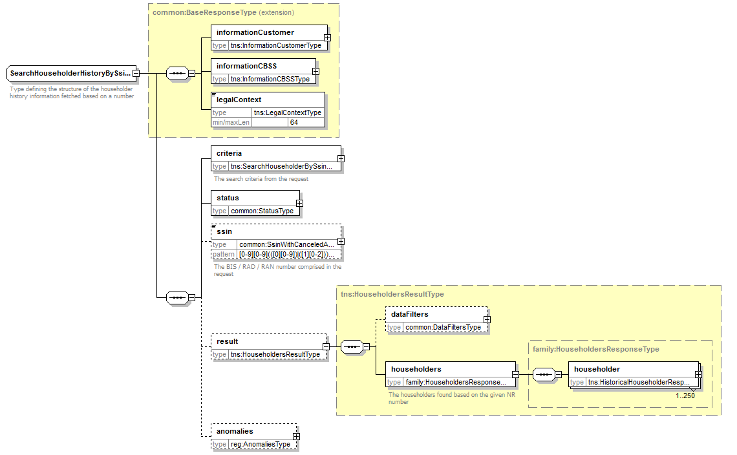
Elément |  |  | Description
informationCustomer |  |  | Repris de la requête
informationCBSS |  |  | Information de la BCSS, voir §5.1.2
legalContext |  |  | Repris de la requête
criteria |  |  | Repris de la requête
status |  |  | Statut de la réponse, voir §5.1.4
ssin |  |  | Le NISS pour lequel on a répondu, voir §5.1.5
result |  |  | Le résultat de la recherche
 | dataFilters |  | Le filtrage des données appliqué
 | householders |  | Les composition de ménage historiques retrouvés
 |  | householder | Voir §5.1.9
anomalies |  |  | Avertissements sur des inconsistances qui  - empêchent de déterminer le chef de ménage  - n'appartiennent pas à un chef de ménage particulière

searchHouseholderBySsinAndDate

Requête
Idem à §5.3.1

Réponse
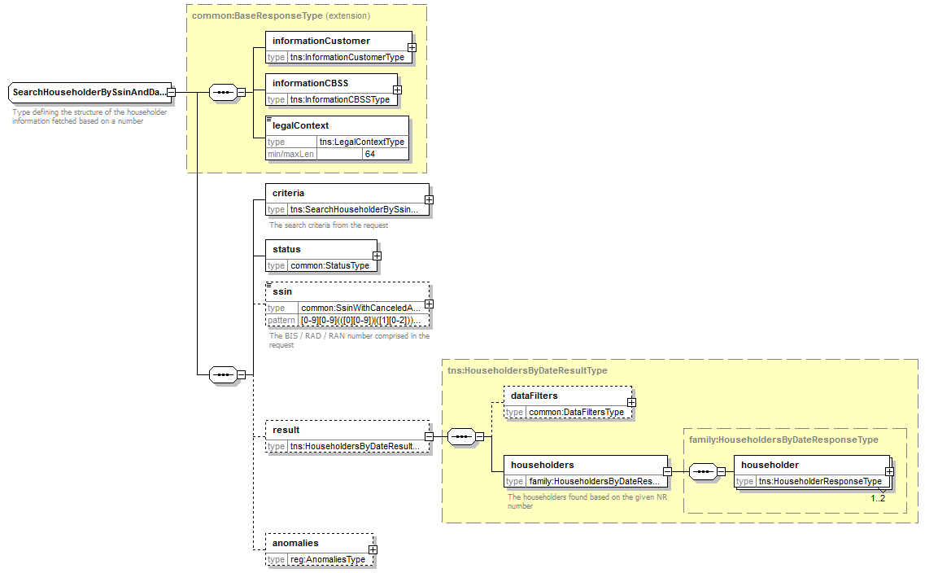
Elément |  |  | Description
informationCustomer |  |  | Repris de la requête
informationCBSS |  |  | Information de la BCSS, voir §5.1.2
legalContext |  |  | Repris de la requête
criteria |  |  | Repris de la requête
status |  |  | Statut de la réponse, voir §5.1.4
ssin |  |  | Le NISS pour lequel on a répondu, voir §5.1.5
result |  |  | Le résultat de la recherche
 | dataFilters |  | Le filtrage des données appliqué
 | householders |  | Les chefs de ménage retrouvés (1, max 2 quand supporté par les registres BCSS)
 |  | householder | Voir §5.1.8
anomalies |  |  | Avertissements sur des inconsistances qui  - empêchent de déterminer le chef de ménage  - n'appartiennent pas à un chef de ménage particulière

Fault
Voir [6].

Codes du statut des réponses BCSS
Voir [6].

Listes de codes
Voir [5].

Disponibilité et performance
La BCSS ne fournit pas de SLA concernant les temps de réponse et la disponibilité des services web du fait que ceux-ci sont dépendant de le source authentique pour laquelle la BCSS n’a aucune compétence et responsabilité.
En ce qui concerne la partie du traitement interne à la BCSS, celle-ci garantie une disponibilité de 98% et les temps de réponse suivant:
90% < 1 seconde et 95% < 2 secondes.
En cas d’interruption du service ou de la connexion avec le Registre national, il est possible que nous interrompions prématurément les connexions afin d’éviter une surcharge des systèmes. Lorsque tel est le cas, une erreur est renvoyée comme lorsqu’un problème (p.ex. timeout) survient lors de la consultation effective du Registre national.

En cas de problèmes
Veuillez contacter le service desk
- par téléphone au numéro 02-741 84 00 entre 8h00 et 16h30 les jours ouvrables,
- par courriel à l’adresse suivante: servicedesk@ksz-bcss.fgov.be.
En vous munissant des informations suivantes:
- Messages soap (question et réponse).
- Ticket du message, il s’agit du ticket BCSS (de préférence) ou de la référence du message que le client a lui-même ajouté au message.
- Date et l’heure de la consultation.
- L’url ou le nom du service ainsi que l’environnement.
- L’environnement dans lequel le problème se manifeste (acceptation ou production).
Si vous souhaitez obtenir de plus amples informations relatives au service desk, nous vous invitons à consulter notre site web.

Best practices

Validation à l’aide d’un WSDL/XSD
Nous recommandons aux partenaires d’effectuer une validation à l’aide du fichier WSDL des requêtes qu’ils nous transmettent. En effet, si la requête n’est pas valide selon le contrat convenu, elle sera refusée.

Format des dates
Dans les champs de type "xs: date", l’utilisation d’une date sans fuseau horaire (ou "Z") est vivement recommandée. Dans certains contextes/programmes, le fuseau horaire peut être interprété, avec comme conséquence que la date résultante peut être différente que la date attendue.

Messages d’exemple

searchFamilyCompositionBySsin

Request
<soapenv:Envelope xmlns:soapenv="http://schemas.xmlsoap.org/soap/envelope/" xmlns:v2="http://kszbcss.fgov.be/intf/registries/FamilyCompositionService/v2">
<soapenv:Header/>
<soapenv:Body>
<v2:searchFamilyCompositionBySsinRequest>
<informationCustomer>
<customerIdentification>
<cbeNumber>********31</cbeNumber>
</customerIdentification>
</informationCustomer>
<legalContext>***************</legalContext>
<criteria>
<ssin>*********87</ssin>
</criteria>
</v2:searchFamilyCompositionBySsinRequest>
</soapenv:Body>
</soapenv:Envelope>

Response
<soap:Envelope xmlns:soap="http://schemas.xmlsoap.org/soap/envelope/">
<soap:Header/>
<soap:Body>
<external:searchFamilyCompositionBySsinResponse xmlns:external="http://kszbcss.fgov.be/intf/registries/FamilyCompositionService/v2">
<informationCustomer>
<customerIdentification>
<cbeNumber>********31</cbeNumber>
</customerIdentification>
</informationCustomer>
<informationCBSS>
<ticketCBSS>1d8742ac-f687-4079-b5e7-c4ed24dd2efe</ticketCBSS>
<timestampReceive>2018-10-24T12:50:09.217Z</timestampReceive>
<timestampReply>2018-10-24T12:50:12.042Z</timestampReply>
</informationCBSS>
<legalContext>***************</legalContext>
<criteria>
<ssin>*********87</ssin>
</criteria>
<status>
<value>DATA_FOUND</value>
<code>MSG00000</code>
<description>Treatment successful</description>
</status>
<ssin>*********87</ssin>
<result>
<familyComposition source="NR">
<familyMembers>
<familyMember source="NR">
<personIdentification>
<ssin>*********87</ssin>
<name>
<lastName>********</lastName>
<givenName sequence="1">****</givenName>
<inceptionDate>****-**-**</inceptionDate>
</name>
<birth>
<birthDate>****-**-**</birthDate>
</birth>
<gender>
<genderCode>F</genderCode>
</gender>
<address>
<residentialAddress>
<countryCode>150</countryCode>
<countryIsoCode>BE</countryIsoCode>
<countryName language="FR">Belgique</countryName>
<countryName language="NL">België</countryName>
<countryName language="DE">Belgien</countryName>
<cityCode>23027</cityCode>
<cityName language="NL">Halle</cityName>
<postalCode>1500</postalCode>
<streetCode>****</streetCode>
<streetName language="NL">**************</streetName>
<houseNumber>*</houseNumber>
<boxNumber>****</boxNumber>
<inceptionDate>****-**-**</inceptionDate>
</residentialAddress>
</address>
<administrator>
<location>
<countryCode>150</countryCode>
<countryIsoCode>BE</countryIsoCode>
<countryName language="FR">Belgique</countryName>
<countryName language="NL">België</countryName>
<countryName language="DE">Belgien</countryName>
<cityCode>23027</cityCode>
<cityName language="NL">Halle</cityName>
</location>
<inceptionDate>****-**-**</inceptionDate>
</administrator>
</personIdentification>
<positionCode>1</positionCode>
<positionDescription language="FR">chef de ménage</positionDescription>
<positionDescription language="NL">gezinshoofd</positionDescription>
<inceptionDate>****-**-**</inceptionDate>
</familyMember>
<familyMember source="NR">
<personIdentification>
<ssin>***********56</ssin>
<name>
<lastName>************</lastName>
<givenName sequence="1">********</givenName>
</name>
<birth>
<birthDate>****-**-**</birthDate>
</birth>
<gender>
<genderCode>M</genderCode>
</gender>
</personIdentification>
<positionCode>2</positionCode>
<positionDescription language="FR">conjoint</positionDescription>
<positionDescription language="NL">echtgenoot/echtgenote</positionDescription>
<inceptionDate>****-**-**</inceptionDate>
</familyMember>
<familyMember source="NR">
<personIdentification>
<ssin>*********75</ssin>
<name>
<lastName>*************</lastName>
<givenName sequence="1">******</givenName>
</name>
<birth>
<birthDate>****-**-**</birthDate>
</birth>
<gender>
<genderCode>F</genderCode>
</gender>
</personIdentification>
<positionCode>3</positionCode>
<positionDescription language="FR">fils/fille</positionDescription>
<positionDescription language="NL">zoon/dochter</positionDescription>
<cohousingCode>0</cohousingCode>
<cohousingDescription language="FR">Ménage non logement collectif</cohousingDescription>
<cohousingDescription language="NL">Gezin niet collectief wonen</cohousingDescription>
<inceptionDate>****-**-**</inceptionDate>
</familyMember>
</familyMembers>
</familyComposition>
</result>
</external:searchFamilyCompositionBySsinResponse>
</soap:Body>
</soap:Envelope>

Fault
<soapenv:Envelope xmlns:soapenv="http://schemas.xmlsoap.org/soap/envelope/">
<soapenv:Body>
<soapenv:Fault>
<faultcode>soapenv:Server</faultcode>
<faultstring>Error in communication with the destination/supplier</faultstring>
<faultactor>http://www.ksz-bcss.fgov.be/</faultactor>
<detail>
<n1:searchFamilyCompositionBySsinFault xmlns:n1="http://kszbcss.fgov.be/intf/registries/FamilyCompositionService/v2">
<informationCustomer>
<customerIdentification>
<cbeNumber>********31</cbeNumber>
</customerIdentification>
</informationCustomer>
<informationCBSS>
<ticketCBSS>1d5ad78d-d41e-4efd-b0f9-a30cb7727eb7</ticketCBSS>
<timestampReceive>2018-11-14T07:42:41.201Z</timestampReceive>
<timestampReply>2018-11-14T07:42:41.492Z</timestampReply>
</informationCBSS>
<detail>
<severity>FATAL</severity>
<reasonCode>MSG00002</reasonCode>
<diagnostic>Error in communication with the destination/supplier</diagnostic>
<authorCode>http://www.ksz-bcss.fgov.be/</authorCode>
</detail>
</n1:searchFamilyCompositionBySsinFault>
</detail>
</soapenv:Fault>
</soapenv:Body>
</soapenv:Envelope>

searchFamilyCompositionHistoryBySsin

Request
<soapenv:Envelope xmlns:soapenv="http://schemas.xmlsoap.org/soap/envelope/" xmlns:v2="http://kszbcss.fgov.be/intf/registries/FamilyCompositionService/v2">
<soapenv:Header/>
<soapenv:Body>
<v2:searchFamilyCompositionHistoryBySsinRequest>
<informationCustomer>
<customerIdentification>
<cbeNumber>********31</cbeNumber>
</customerIdentification>
</informationCustomer>
<legalContext>***************</legalContext>
<criteria>
<ssin>*********82</ssin>
</criteria>
</v2:searchFamilyCompositionHistoryBySsinRequest>
</soapenv:Body>
</soapenv:Envelope>

Response
<soap:Envelope xmlns:soap="http://schemas.xmlsoap.org/soap/envelope/">
<soap:Header/>
<soap:Body>
<external:searchFamilyCompositionHistoryBySsinResponse xmlns:external="http://kszbcss.fgov.be/intf/registries/FamilyCompositionService/v2">
<informationCustomer>
<customerIdentification>
<cbeNumber>********31</cbeNumber>
</customerIdentification>
</informationCustomer>
<informationCBSS>
<ticketCBSS>a027c0ba-8d26-44d9-b7cf-54fe023f9ea0</ticketCBSS>
<timestampReceive>2018-10-24T12:56:59.663Z</timestampReceive>
<timestampReply>2018-10-24T12:57:01.405Z</timestampReply>
</informationCBSS>
<legalContext>***************</legalContext>
<criteria>
<ssin>*********82</ssin>
</criteria>
<status>
<value>DATA_FOUND</value>
<code>MSG00000</code>
<description>Treatment successful</description>
</status>
<ssin>*********82</ssin>
<result>
<familyCompositions>
<familyComposition source="NR">
<familyMembers>
<familyMember source="NR">
<personIdentification>
<ssin>*********82</ssin>
<name>
<lastName>**********</lastName>
<givenName sequence="1">******</givenName>
<inceptionDate>****-**-**</inceptionDate>
</name>
<birth>
<birthDate>****-**-**</birthDate>
</birth>
<gender>
<genderCode>M</genderCode>
</gender>
</personIdentification>
<positionCode>1</positionCode>
<positionDescription language="FR">chef de ménage</positionDescription>
<positionDescription language="NL">gezinshoofd</positionDescription>
<inceptionDate>1966-**-**</inceptionDate>
<expiryDate>2008-**-**</expiryDate>
</familyMember>
<familyMember source="NR">
<personIdentification>
<ssin>*********89</ssin>
<name>
<lastName>********</lastName>
<givenName sequence="1">*****</givenName>
<givenName sequence="2">******</givenName>
<givenName sequence="3">*******</givenName>
</name>
<birth>
<birthDate>****-**-**</birthDate>
</birth>
<gender>
<genderCode>F</genderCode>
</gender>
</personIdentification>
<positionCode>2</positionCode>
<positionDescription language="FR">conjoint</positionDescription>
<positionDescription language="NL">echtgenoot/echtgenote</positionDescription>
<inceptionDate>1966-**-**</inceptionDate>
<expiryDate>2008-**-**</expiryDate>
</familyMember>
<familyMember source="NR">
<personIdentification>
<ssin>*********72</ssin>
<name>
<lastName>**********</lastName>
<givenName sequence="1">******</givenName>
<givenName sequence="2">*******</givenName>
<givenName sequence="3">******</givenName>
</name>
<birth>
<birthDate>****-**-**</birthDate>
</birth>
<gender>
<genderCode>F</genderCode>
</gender>
</personIdentification>
<positionCode>3</positionCode>
<positionDescription language="FR">fils/fille</positionDescription>
<positionDescription language="NL">zoon/dochter</positionDescription>
<inceptionDate>1966-**-**</inceptionDate>
<expiryDate>1980-**-**</expiryDate>
</familyMember>
<familyMember source="NR">
<personIdentification>
<ssin>*********10</ssin>
<name>
<lastName>**********</lastName>
<givenName sequence="1">********</givenName>
<givenName sequence="2">*****</givenName>
<givenName sequence="3">*******</givenName>
</name>
<birth>
<birthDate>****-**-**</birthDate>
</birth>
<gender>
<genderCode>F</genderCode>
</gender>
</personIdentification>
<positionCode>3</positionCode>
<positionDescription language="FR">fils/fille</positionDescription>
<positionDescription language="NL">zoon/dochter</positionDescription>
<inceptionDate>1966-**-**</inceptionDate>
<expiryDate>1981-**-**</expiryDate>
</familyMember>
<familyMember source="NR">
<personIdentification>
<ssin>*********88</ssin>
<name>
<lastName>**********</lastName>
<givenName sequence="1">*****</givenName>
<givenName sequence="2">*******</givenName>
<givenName sequence="3">******</givenName>
</name>
<birth>
<birthDate>****-**-**</birthDate>
</birth>
<gender>
<genderCode>F</genderCode>
</gender>
</personIdentification>
<positionCode>3</positionCode>
<positionDescription language="FR">fils/fille</positionDescription>
<positionDescription language="NL">zoon/dochter</positionDescription>
<inceptionDate>1966-**-**</inceptionDate>
<expiryDate>1989-**-**</expiryDate>
</familyMember>
<familyMember source="NR">
<personIdentification>
<ssin>*********07</ssin>
<name>
<lastName>**********</lastName>
<givenName sequence="1">*****</givenName>
<givenName sequence="2">********</givenName>
<givenName sequence="3">****</givenName>
</name>
<birth>
<birthDate>****-**-**</birthDate>
</birth>
<gender>
<genderCode>M</genderCode>
</gender>
</personIdentification>
<positionCode>3</positionCode>
<positionDescription language="FR">fils/fille</positionDescription>
<positionDescription language="NL">zoon/dochter</positionDescription>
<inceptionDate>1966-**-**</inceptionDate>
<expiryDate>2004-**-**</expiryDate>
</familyMember>
</familyMembers>
<anomalies>
<anomaly>
<code>400512</code>
<description>Householder deceased. Decease date used as expiry date for open members.</description>
<information>
<fieldName>Decease Date</fieldName>
<fieldValue>2008-**-**</fieldValue>
</information>
<information>
<fieldName>Ssin</fieldName>
<fieldValue>*********82</fieldValue>
</information>
</anomaly>
</anomalies>
</familyComposition>
</familyCompositions>
</result>
</external:searchFamilyCompositionHistoryBySsinResponse>
</soap:Body>
</soap:Envelope>

Fault
<soapenv:Envelope xmlns:soapenv="http://schemas.xmlsoap.org/soap/envelope/">
<soapenv:Body>
<soapenv:Fault>
<faultcode>soapenv:Server</faultcode>
<faultstring>Error in communication with the destination/supplier</faultstring>
<faultactor>http://www.ksz-bcss.fgov.be/</faultactor>
<detail>
<n1:searchFamilyCompositionHistoryBySsinFault xmlns:n1="http://kszbcss.fgov.be/intf/registries/FamilyCompositionService/v2">
<informationCustomer>
<customerIdentification>
<cbeNumber>********31</cbeNumber>
</customerIdentification>
</informationCustomer>
<informationCBSS>
<ticketCBSS>3b947667-38a2-4acc-a5de-39ec866a05ac</ticketCBSS>
<timestampReceive>2018-11-14T07:42:46.055Z</timestampReceive>
<timestampReply>2018-11-14T07:42:46.326Z</timestampReply>
</informationCBSS>
<detail>
<severity>FATAL</severity>
<reasonCode>MSG00002</reasonCode>
<diagnostic>Error in communication with the destination/supplier</diagnostic>
<authorCode>http://www.ksz-bcss.fgov.be/</authorCode>
</detail>
</n1:searchFamilyCompositionHistoryBySsinFault>
</detail>
</soapenv:Fault>
</soapenv:Body>
</soapenv:Envelope>

searchFamilyCompositionBySsinAndDate

Request
<soapenv:Envelope xmlns:soapenv="http://schemas.xmlsoap.org/soap/envelope/" xmlns:v2="http://kszbcss.fgov.be/intf/registries/FamilyCompositionService/v2">
<soapenv:Header/>
<soapenv:Body>
<v2:searchFamilyCompositionBySsinAndDateRequest>
<informationCustomer>
<customerIdentification>
<cbeNumber>********31</cbeNumber>
</customerIdentification>
</informationCustomer>
<legalContext>***************</legalContext>
<criteria>
<ssin>*********07</ssin>
<date>2000-01-01</date>
</criteria>
</v2:searchFamilyCompositionBySsinAndDateRequest>
</soapenv:Body>
</soapenv:Envelope>

Response
<soap:Envelope xmlns:soap="http://schemas.xmlsoap.org/soap/envelope/">
<soap:Header/>
<soap:Body>
<external:searchFamilyCompositionBySsinAndDateResponse xmlns:external="http://kszbcss.fgov.be/intf/registries/FamilyCompositionService/v2">
<informationCustomer>
<customerIdentification>
<cbeNumber>********31</cbeNumber>
</customerIdentification>
</informationCustomer>
<informationCBSS>
<ticketCBSS>dbe688e3-fbb8-4f98-8fb6-1eae798fac26</ticketCBSS>
<timestampReceive>2018-10-24T13:10:39.972Z</timestampReceive>
<timestampReply>2018-10-24T13:10:40.615Z</timestampReply>
</informationCBSS>
<legalContext>***************</legalContext>
<criteria>
<ssin>*********07</ssin>
<date>2000-01-01</date>
<status>
<value>DATA_FOUND</value>
<code>MSG00000</code>
<description>Treatment successful</description>
</status>
<ssin>*********07</ssin>
<result>
<familyCompositions>
<familyComposition source="NR">
<familyMembers>
<familyMember source="NR">
<personIdentification>
<ssin>*********07</ssin>
<name>
<lastName>******</lastName>
<givenName sequence="1">*****</givenName>
<inceptionDate>****-**-**</inceptionDate>
</name>
<birth>
<birthDate>****-**-**</birthDate>
</birth>
<gender>
<genderCode>F</genderCode>
</gender>
</personIdentification>
<positionCode>1</positionCode>
<positionDescription language="FR">chef de ménage</positionDescription>
<positionDescription language="NL">gezinshoofd</positionDescription>
<inceptionDate>1994-**-**</inceptionDate>
</familyMember>
<familyMember source="NR">
<personIdentification>
<ssin>*********76</ssin>
<name>
<lastName>*******</lastName>
<givenName sequence="1">****</givenName>
<givenName sequence="2">*****</givenName>
</name>
<birth>
<birthDate>****-**-**</birthDate>
</birth>
<gender>
<genderCode>F</genderCode>
</gender>
</personIdentification>
<positionCode>6</positionCode>
<positionDescription language="FR">père/mère</positionDescription>
<positionDescription language="NL">vader/moeder</positionDescription>
<inceptionDate>1994-**-**</inceptionDate>
</familyMember>
</familyMembers>
<anomalies>
</familyComposition>
</familyCompositions>
</result>
</external:searchFamilyCompositionBySsinAndDateResponse>
</soap:Body>
</soap:Envelope>

Fault
<soapenv:Envelope xmlns:soapenv="http://schemas.xmlsoap.org/soap/envelope/">
<soapenv:Body>
<soapenv:Fault>
<faultcode>soapenv:Server</faultcode>
<faultstring>Error in communication with the destination/supplier</faultstring>
<faultactor>http://www.ksz-bcss.fgov.be/</faultactor>
<detail>
<n1:searchFamilyCompositionBySsinAndDateFault xmlns:n1="http://kszbcss.fgov.be/intf/registries/FamilyCompositionService/v2">
<informationCustomer>
<customerIdentification>
<cbeNumber>********31</cbeNumber>
</customerIdentification>
</informationCustomer>
<informationCBSS>
<ticketCBSS>3b947667-38a2-4acc-a5de-39ec866a05ac</ticketCBSS>
<timestampReceive>2018-11-14T07:42:46.055Z</timestampReceive>
<timestampReply>2018-11-14T07:42:46.326Z</timestampReply>
</informationCBSS>
<detail>
<severity>FATAL</severity>
<reasonCode>MSG00002</reasonCode>
<diagnostic>Error in communication with the destination/supplier</diagnostic>
<authorCode>http://www.ksz-bcss.fgov.be/</authorCode>
</detail>
</n1:searchFamilyCompositionBySsinAndDateFault>
</detail>
</soapenv:Fault>
</soapenv:Body>
</soapenv:Envelope>

searchHouseholderBySsin

Request
<soapenv:Envelope xmlns:soapenv="http://schemas.xmlsoap.org/soap/envelope/" xmlns:v2="http://kszbcss.fgov.be/intf/registries/FamilyCompositionService/v2">
<soapenv:Header/>
<soapenv:Body>
<v2:searchHouseholderBySsinRequest>
<informationCustomer>
<customerIdentification>
<cbeNumber>********31</cbeNumber>
</customerIdentification>
</informationCustomer>
<legalContext>***************</legalContext>
<criteria>
<ssin>*********82</ssin>
</criteria>
</v2:searchHouseholderBySsinRequest>
</soapenv:Body>
</soapenv:Envelope>

Response
<soap:Envelope xmlns:soap="http://schemas.xmlsoap.org/soap/envelope/">
<soap:Header/>
<soap:Body>
<external:searchHouseholderBySsinResponse xmlns:external="http://kszbcss.fgov.be/intf/registries/FamilyCompositionService/v2">
<informationCustomer>
<customerIdentification>
<cbeNumber>********31</cbeNumber>
</customerIdentification>
</informationCustomer>
<informationCBSS>
<ticketCBSS>81237db0-f75e-41b0-b84b-912b94c1de56</ticketCBSS>
<timestampReceive>2018-10-24T13:14:41.526Z</timestampReceive>
<timestampReply>2018-10-24T13:14:42.554Z</timestampReply>
</informationCBSS>
<legalContext>***************</legalContext>
<criteria>
<ssin>*********76</ssin>
</criteria>
<status>
<value>DATA_FOUND</value>
<code>MSG00000</code>
<description>Treatment successful</description>
</status>
<ssin>*********76</ssin>
<result>
<householder source="NR">
<personIdentification>
<ssin>*********76</ssin>
<name>
<lastName>*******</lastName>
<givenName sequence="1">****</givenName>
<givenName sequence="2">*****</givenName>
</name>
<birth>
<birthDate>****-**-**</birthDate>
</birth>
<gender>
<genderCode>F</genderCode>
</gender>
</personIdentification>
<positionCode>1</positionCode>
<positionDescription language="FR">chef de ménage</positionDescription>
<positionDescription language="NL">gezinshoofd</positionDescription>
</householder>
</result>
</external:searchHouseholderBySsinResponse>
</soap:Body>
</soap:Envelope>

Fault
<soapenv:Envelope xmlns:soapenv="http://schemas.xmlsoap.org/soap/envelope/">
<soapenv:Body>
<soapenv:Fault>
<faultcode>soapenv:Server</faultcode>
<faultstring>Error in communication with the destination/supplier</faultstring>
<faultactor>http://www.ksz-bcss.fgov.be/</faultactor>
<detail>
<n1:searchHouseholderBySsinFault xmlns:n1="http://kszbcss.fgov.be/intf/registries/FamilyCompositionService/v2">
<informationCustomer>
<customerIdentification>
<cbeNumber>********31</cbeNumber>
</customerIdentification>
</informationCustomer>
<informationCBSS>
<ticketCBSS>7761448a-3dd4-4b0f-b28e-9a8eb922ac83</ticketCBSS>
<timestampReceive>2018-11-14T07:42:11.483Z</timestampReceive>
<timestampReply>2018-11-14T07:42:16.260Z</timestampReply>
</informationCBSS>
<detail>
<severity>FATAL</severity>
<reasonCode>MSG00002</reasonCode>
<diagnostic>Error in communication with the destination/supplier</diagnostic>
<authorCode>http://www.ksz-bcss.fgov.be/</authorCode>
</detail>
</n1:searchHouseholderBySsinFault>
</detail>
</soapenv:Fault>
</soapenv:Body>
</soapenv:Envelope>

searchHouseholderHistoryBySsin

Request
<soapenv:Envelope xmlns:soapenv="http://schemas.xmlsoap.org/soap/envelope/" xmlns:v2="http://kszbcss.fgov.be/intf/registries/FamilyCompositionService/v2">
<soapenv:Header/>
<soapenv:Body>
<v2:searchHouseholderHistoryBySsinRequest>
<informationCustomer>
<customerIdentification>
<cbeNumber>********31</cbeNumber>
</customerIdentification>
</informationCustomer>
<legalContext>***************</legalContext>
<criteria>
<ssin>*********25</ssin>
</criteria>
</v2:searchHouseholderHistoryBySsinRequest>
</soapenv:Body>
</soapenv:Envelope>

Response
<soap:Envelope xmlns:soap="http://schemas.xmlsoap.org/soap/envelope/">
<soap:Header/>
<soap:Body>
<external:searchHouseholderHistoryBySsinResponse xmlns:external="http://kszbcss.fgov.be/intf/registries/FamilyCompositionService/v2">
<informationCustomer>
<customerIdentification>
<cbeNumber>********31</cbeNumber>
</customerIdentification>
</informationCustomer>
<informationCBSS>
<ticketCBSS>6301608e-bfc5-482c-ae3d-36feab129a46</ticketCBSS>
<timestampReceive>2018-10-24T13:20:12.546Z</timestampReceive>
<timestampReply>2018-10-24T13:20:13.494Z</timestampReply>
</informationCBSS>
<legalContext>***************</legalContext>
<criteria>
<ssin>*********25</ssin>
</criteria>
<status>
<value>DATA_FOUND</value>
<code>MSG00000</code>
<description>Treatment successful</description>
</status>
<ssin>*********25</ssin>
<result>
<householders>
<householder source="NR">
<personIdentification>
<ssin>*********25</ssin>
<name>
<lastName>*************</lastName>
<givenName sequence="1">*****</givenName>
<inceptionDate>****-**-**</inceptionDate>
</name>
<birth>
<birthDate>****-**-**</birthDate>
</birth>
<gender>
<genderCode>M</genderCode>
</gender>
</personIdentification>
<positionCode>1</positionCode>
<positionDescription language="FR">chef de ménage</positionDescription>
<positionDescription language="NL">gezinshoofd</positionDescription>
<inceptionDate>2006-**-**</inceptionDate>
</householder>
<householder source="NR">
<personIdentification>
<ssin>*********27</ssin>
<name>
<lastName>*****</lastName>
<givenName sequence="1">**********</givenName>
</name>
<birth>
<birthDate>****-**-**</birthDate>
</birth>
<gender>
<genderCode>F</genderCode>
</gender>
</personIdentification>
<positionCode>3</positionCode>
<positionDescription language="FR">fils/fille</positionDescription>
<positionDescription language="NL">zoon/dochter</positionDescription>
<inceptionDate>2003-**-**</inceptionDate>
<expiryDate>2006-**-**</expiryDate>
</householder>
<householder source="NR">
<personIdentification>
<ssin>*********89</ssin>
<name>
<lastName>*************</lastName>
<givenName sequence="1">***</givenName>
<givenName sequence="2">******</givenName>
<givenName sequence="3">*****</givenName>
</name>
<birth>
<birthDate>****-**-**</birthDate>
</birth>
<gender>
<genderCode>M</genderCode>
</gender>
</personIdentification>
<positionCode>3</positionCode>
<positionDescription language="FR">fils/fille</positionDescription>
<positionDescription language="NL">zoon/dochter</positionDescription>
<inceptionDate>1982-**-**</inceptionDate>
<expiryDate>2003-**-**</expiryDate>
</householder>
</householders>
</result>
</external:searchHouseholderHistoryBySsinResponse>
</soap:Body>
</soap:Envelope>

Fault
<soapenv:Envelope xmlns:soapenv="http://schemas.xmlsoap.org/soap/envelope/">
<soapenv:Body>
<soapenv:Fault>
<faultcode>soapenv:Server</faultcode>
<faultstring>Error in communication with the destination/supplier</faultstring>
<faultactor>http://www.ksz-bcss.fgov.be/</faultactor>
<detail>
<n1:searchHouseholderHistoryBySsinFault xmlns:n1="http://kszbcss.fgov.be/intf/registries/FamilyCompositionService/v2">
<informationCustomer>
<customerIdentification>
<cbeNumber>********31</cbeNumber>
</customerIdentification>
</informationCustomer>
<informationCBSS>
<ticketCBSS>7761448a-3dd4-4b0f-b28e-9a8eb922ac83</ticketCBSS>
<timestampReceive>2018-11-14T07:42:11.483Z</timestampReceive>
<timestampReply>2018-11-14T07:42:16.260Z</timestampReply>
</informationCBSS>
<detail>
<severity>FATAL</severity>
<reasonCode>MSG00002</reasonCode>
<diagnostic>Error in communication with the destination/supplier</diagnostic>
<authorCode>http://www.ksz-bcss.fgov.be/</authorCode>
</detail>
</n1:searchHouseholderHistoryBySsinFault>
</detail>
</soapenv:Fault>
</soapenv:Body>
</soapenv:Envelope>

searchHouseholderBySsinAndDate

Request
<soapenv:Envelope xmlns:soapenv="http://schemas.xmlsoap.org/soap/envelope/" xmlns:v2="http://kszbcss.fgov.be/intf/registries/FamilyCompositionService/v2">
<soapenv:Header/>
<soapenv:Body>
<v2:searchHouseholderBySsinAndDateRequest>
<informationCustomer>
<customerIdentification>
<cbeNumber>********31</cbeNumber>
</customerIdentification>
</informationCustomer>
<legalContext>***************</legalContext>
<criteria>
<ssin>*********82</ssin>
<date>2007-01-01</date>
</criteria>
</v2:searchHouseholderBySsinAndDateRequest>
</soapenv:Body>
</soapenv:Envelope>

Response
<soap:Envelope xmlns:soap="http://schemas.xmlsoap.org/soap/envelope/">
<soap:Header/>
<soap:Body>
<external:searchHouseholderBySsinAndDateResponse xmlns:external="http://kszbcss.fgov.be/intf/registries/FamilyCompositionService/v2">
<informationCustomer>
<customerIdentification>
<cbeNumber>********31</cbeNumber>
</customerIdentification>
</informationCustomer>
<informationCBSS>
<ticketCBSS>3e1ee81a-3382-4dc9-afe5-0cba014f84ae</ticketCBSS>
<timestampReceive>2018-10-24T13:24:14.195Z</timestampReceive>
<timestampReply>2018-10-24T13:24:14.866Z</timestampReply>
</informationCBSS>
<legalContext>***************</legalContext>
<criteria>
<ssin>*********82</ssin>
<date>2007-01-01</date>
</criteria>
<status>
<value>DATA_FOUND</value>
<code>MSG00000</code>
<description>Treatment successful</description>
</status>
<ssin>*********82</ssin>
<result>
<householders>
<householder source="NR">
<personIdentification>
<ssin>*********82</ssin>
<name>
<lastName>**********</lastName>
<givenName sequence="1">******</givenName>
<inceptionDate>****-**-**</inceptionDate>
</name>
<birth>
<birthDate>****-**-**</birthDate>
</birth>
<gender>
<genderCode>M</genderCode>
</gender>
</personIdentification>
<positionCode>1</positionCode>
<positionDescription language="FR">chef de ménage</positionDescription>
<positionDescription language="NL">gezinshoofd</positionDescription>
<inceptionDate>1966-**-**</inceptionDate>
<anomalies>
<anomaly>
<code>400512</code>
<description>Householder deceased. Decease date used as expiry date for open members.</description>
<information>
<fieldName>Decease Date</fieldName>
<fieldValue>2008-07-31</fieldValue>
</information>
<information>
<fieldName>Ssin</fieldName>
<fieldValue>*********82</fieldValue>
</information>
</anomaly>
</anomalies>
</householder>
</householders>
</result>
</external:searchHouseholderBySsinAndDateResponse>
</soap:Body>
</soap:Envelope>

Fault
<soapenv:Envelope xmlns:soapenv="http://schemas.xmlsoap.org/soap/envelope/">
<soapenv:Body>
<soapenv:Fault>
<faultcode>soapenv:Server</faultcode>
<faultstring>Error in communication with the destination/supplier</faultstring>
<faultactor>http://www.ksz-bcss.fgov.be/</faultactor>
<detail>
<n1:searchHouseholderBySsinAndDateFault xmlns:n1="http://kszbcss.fgov.be/intf/registries/FamilyCompositionService/v2">
<informationCustomer>
<customerIdentification>
<cbeNumber>********31</cbeNumber>
</customerIdentification>
</informationCustomer>
<informationCBSS>
<ticketCBSS>196e2037-26f6-4556-9156-93c88ec9055d</ticketCBSS>
<timestampReceive>2018-11-14T07:42:15.813Z</timestampReceive>
<timestampReply>2018-11-14T07:42:18.082Z</timestampReply>
</informationCBSS>
<detail>
<severity>FATAL</severity>
<reasonCode>MSG00002</reasonCode>
<diagnostic>Error in communication with the destination/supplier</diagnostic>
<authorCode>http://www.ksz-bcss.fgov.be/</authorCode>
</detail>
</n1:searchHouseholderBySsinAndDateFault>
</detail>
</soapenv:Fault>
</soapenv:Body>
</soapenv:Envelope>

Annexes

Construction of the family composition
Due to the specific logic used by the National Registry for TI 141 and 140, we have implemented a specific algorithm to construct the (current and historical) family compositions.

By SSIN
The current family composition is calculated using the algorithm below.
- Fetch the person data for the requested SSIN: householder (TI 141), family members (TI 140) and decease (TI 150).
- Validate the response.
  - If the SSIN is canceled, return error (MSG00007).
  - If the SSIN is replaced, use the replacing SSIN as requested SSIN and return to step 1.
  - If the person is deceased (TI 150 present), return error (REG00012).
  - If person has both householder and family members at the same time, return error (REG00009).
- Determine the householder. If the data of TI 141 contains the SSIN of a householder which is not the person itself, this SSIN is the householder. In all other cases, the person is his own householder. Note that if TI 141 contains position code 20, there is no SSIN, we consider the person itself as his own householder with position code 20.
- If the householder differs from the person, fetch his data and validate the response.
  - The person data for the householder is fetched: householder (TI 141), family members (TI 140) and decease (TI 150).
  - If the householder SSIN is canceled, return error (REG00019).
  - If the householder SSIN is replaced, use the replacing SSIN as householder SSIN and return to step (a).
  - If the householder has both householder and family members at the same time, return error (REG00009).
  - If the householder is deceased (TI 150 present), return error (REG00018).
- Create the family composition based on the input
  - Get the family members from the TI 140 of the householder
  - Add the householder as family member
- Detect anomalies in the data and add warnings for them
  - If a family member appears multiple times in the composition (code 400504)
  - If the inception date of the householder (TI 141) does not correspond to the inception date of the requested SSIN as family member of the householder (TI 140 of the householder) (code 400505)
  - If the requested SSIN does not appear in the composition (of the householder that was not the person itself) (code 400506)
  - If a family member appears multiple times in the composition of which at least once as householder (code 400507)
  - If multiple householders exist (from TI 140) (code 400508)

Exemple: personne demandé est chef de ménage
The family composition is requested for A. Green = situation in the NR. Blue = result of the composition.
- Persoon alleenstaand
SSIN | 001 | 002 | 140 | 141 | 150
A | Brussel |  | 1: A [2000-01-01]

SSIN | POSITION | INCEPTION DATE
A | 1: gezinshoofd | 2000-01-01

- Persoon in gemeenschappen
SSIN | 001 | 002 | 140 | 141 | 150
A | Brussel |  |  | 20: A [2000-01-01]

SSIN | POSITION | INCEPTION DATE
A | 20: gemeenschappen | 2000-01-01

- Persoon is gezinshoofd met gezinsleden
SSIN | 001 | 002 | 140 | 141 | 150
A | Brussel |  | 2: K [2001-01-01]  3: L [2002-01-01]

SSIN | POSITION | INCEPTION DATE
A | 1: gezinshoofd
K | 2: echtgeno(o)t(e) | 2001-01-01
L | 3: zoon/dochter | 2002-01-01

Exemple: personne demandé n’est pas chef de ménage
The family composition is requested for A. Green = situation in the NR. Blue = result of the composition.

- Persoon in gezin van echtgeno(o)t(e)
SSIN | 001 | 002 | 140 | 141 | 150
A | Brussel |  |  | 2: M [2000-01-01]
M | Brussel |  | 2: A [2000-01-01]

SSIN | POSITION | INCEPTION DATE
M | 1: gezinshoofd
A | 2: echtgeno(o)t(e) | 2000-01-01

Exemples: anomalies bloquants
The family composition is requested for A. Green = situation in the NR. Blue = result of the composition.

- Anomalie ERROR MSG00007: dossier geannuleerd

SSIN | 001 | 002 | 140 | 141 | 150
A | 99994 ANNUL

- Anomalie ERROR REG00012: persoon overleden
SSIN | 001 | 002 | 140 | 141 | 150
A | 99990 OVERLEDEN |  |  |  | X

- Anomalie ERROR REG00009: meerdere gezinshoofden voor dezelfde periode
Indien A gezinshoofd
SSIN | 001 | 002 | 140 | 141 | 150
A | Brussel |  | 3: L [2002-01-01] | 3: M [2002-01-01]

Indien A geen gezinshoofd
SSIN | 001 | 002 | 140 | 141 | 150
A | Brussel |  |  | 3: M [2002-01-01]
N | Brussel |  | 3: A [2002-01-01] | 3: N [2002-01-01]

- Anomalie ERROR REG00018: gezinshoofd overleden
SSIN | 001 | 002 | 140 | 141 | 150
A | Brussel |  |  | 2: M [2000-01-01]
M | 99990 OVERLEDEN |  |  |  | X

- Anomalie ERROR REG00019: gezinshoofd geannuleerd
SSIN | 001 | 002 | 140 | 141 | 150
A | Brussel |  |  | 2: M [2000-01-01]
M | 99994 ANNUL

History By SSIN
To obtain the complete history the following steps are executed:
- Get the householders
Get the householders for the requested SSIN via TI 141. Each householder has a period for which he/she was householder of the requested person. As a general concept, the National Registry will only show ‘other’ householders and return nothing for the periods in which the person is his own householder.
1991 - 2001  Householder Y | 2000 - 2005  HouseHolder X | 2005 - …  HouseHolder X | 2011 - 2012  HouseHolder Y | 2012-2013  HouseHolder C

- Get the family members for householders with open period, and close periods
Whenever a householder has an open period, fetch the family members for that householder. Close the period of the householder by using the end date of the request person in the family of the householder.
1991 - 2001  Householder Y | 2000 - 2005  HouseHolder X | 2005 - 2009  HouseHolder X | 2011 - 2012 HouseHolder Y | 2012-2013  HouseHolder C
- Warning 400505: period of requested member differs from the period of householder X

- Merge the periods for the same householder
When the same householder appears as several consecutive periods in the requested person’s householder history, merge this periods. This is possible when the position of the requested person relative to the householder has changed. But since the family itself has not really changed, we will merge those periods.
1991 - 2001  Householder Y | 2000 - 2009  HouseHolder X |  | 2011 - 2012 HouseHolder Y | 2012-2013  HouseHolder C
- Warning 400505: period of requested member differs from the period of householder X

- Validate the householder list
Validate the periods of the householders. The National Registry does not guarantee any logic in these periods. Add a warning if periods overlap, if a period has an end date which lies before the start date, or for an open period that is not actual. Also add warnings for consecutive but separate periods with the same householder and same position code.
1991 - 2001  Householder Y | 2000 - 2009  HouseHolder X |  | 2011 - 2012 HouseHolder Y | 2012-2013  HouseHolder C
- Warning 400505: period of requested member differs from the period of householder X
- Warning 400502: period overlap for householder Y

- Get all the family members for all the householders including the person itself
Get all the family members for all the householders in the householder list and the person itself via TI 140. As a general rule, this TI will contain either all the ‘other’ members from the household, if the household contains other members. If the household consist only of the householder, only in that case, the 140 will contain the householder himself as member.

HouseHolder SELF
* self 2010 - 2011
* partner 2013 - now
* son 2013 - now
* daughter 2014 - now
HouseHolder X (died in 2012)
* self 2000 - 2005
* self 2005 - 2009
* sister 1980 - 1999
* brother 1990 - now
HouseHolder Y
* self 1990 - 2000
* other 2005 - now

HouseHolder C
cancelled

- Sort the family member situations in the householder list
Sort the situations of the family member history in the householder list based on the periods of the person itself. Whenever in the history of the person itself other persons appear, the person itself must be assigned as default householder.
1991 - 2001  Householder Y | 2000 - 2009  HouseHolder X |  | 2011 - 2012 HouseHolder Y | 2012-2013  HouseHolder C

HouseHolder SELF
* self 2010 - 2011
* partner 2013 - now
* son 2013 - now
* daughter 2014 - now
HouseHolder X (died in 2012)
* self 2000 - 2005
* self 2005 - 2009
* sister 1980 - 1999
* brother 1990 - now
HouseHolder Y
* self 1990 - 2000
* other 2005 - now

HouseHolder C
cancelled

Gap | 1991 - 2001  HouseHolder Y  * self 1990 - 2000  * other 2005 - now | 2000-2009  HouseHolder X (died in 2012)  * self 2000 - 2005  * self 2005 - 2009  * sister 1980 - 1999  * brother 1990 - now | Gap | 2010 – 2011 HouseHolder SELF  * self 2010 - 2011  * child 2013 - now  * partner 2013 - now | 2011-2012 HouseHolder Y  * self 1990 - 2000  * other 2005 - now | 2012-2013  HouseHolder C  cancelled | 2013 – Now  HouseHolder SELF  * self 2010 - 2011  * partner 2013 - now  * son 2013 - now  * daughter 2014 - now
- Warning 400505: period of requested member differs from the period of householder X
- Warning 400502: period overlap for householder Y
- Warning 400516: householder C is cancelled

- Expire all members in a household where the householder is deceased
In case a householder for which the members are fetched is deceased any member returned with an open period is expired. If this is done, the warning 400512 is added to the response.
Gap | 1991 - 2001  HouseHolder Y  * self 1990 - 2000  * other 2005 - now | 2000-2009  HouseHolder X (died in 2012)  * self 2000 - 2005  * self 2005 - 2009  * sister 1980 - 1999  * brother 1990 - 2012 | Gap | 2010 – 2011 HouseHolder SELF  * self 2010 - 2011  * child 2013 - now  * partner 2013 - now | 2011-2012 HouseHolder Y  * self 1990 - 2000  * other 2005 - now | 2012-2013  HouseHolder C  cancelled | 2013 – Now  HouseHolder SELF  * self 2010 - 2011  * partner 2013 - now  * son 2013 - now  * daughter 2014 - now
- Warning 400505: period of requested member differs from the period of householder X
- Warning 400502: period overlap for householder Y
- Warning 400516: householder C is cancelled
- Warning 400512: householder X was deceased, filled in decease date as end date for “brother”

- Filter the family compositions with cancelled householder
Filter out the family compositions for householders with a canceled SSIN. For these householders, the family members cannot be retrieved because the data at the NR are made inaccessible. Hence, it cannot be used as a valid family composition, which results in a gap in the family composition history for the period of the cancelled householder.
Gap | 1991 - 2001  HouseHolder Y  * self 1990 - 2000  * other 2005 - now | 2000-2009  HouseHolder X (died in 2012)  * self 2000 - 2005  * self 2005 - 2009  * sister 1980 - 1999  * brother 1990 - 2012 | Gap | 2010 – 2011 HouseHolder SELF  * self 2010 – 2011  * child 2013 - now  * partner 2013 - now | 2011-2012 HouseHolder Y  * self 1990 – 2000  * other 2005 - now | Gap | 2013 – Now  HouseHolder SELF  * self 2010 - 2011  * partner 2013 - now  * son 2013 - now  * daughter 2014 - now
- Warning 400505: period of requested member differs from the period of householder X
- Warning 400502: period overlap for householder Y
- Warning 400516: householder C is cancelled
- Warning 400512: householder X was deceased, filled in decease date as end date for “brother”

- Filter the family members per householder by period
Filter out the family members not present during the period in which the requested person resided with this household. This needs to be done because TI 140 gives all the family members for the requested householders, and off course does not discern in the period in which we are interested.
Gap | 1991 - 2001  HouseHolder Y  * self 1990 - 2000  * other 2005 - now | 2000-2009  HouseHolder X (died in 2012)  * self 2000 - 2005  * self 2005 - 2009  * sister 1980 - 1999  * brother 1990 - 2012 | Gap | 2010 – 2011 HouseHolder SELF  * self 2010 - 2011  * child 2013 - now  * partner 2013 - now | 2011-2012 HouseHolder Y  * self 1990 - 2000  * other 2005 - now | Gap | 2013 – Now  HouseHolder SELF  * self 2010 - 2011  * partner 2013 - now  * son 2013 - now  * daughter 2014 - now
- Warning 400505: period of requested member differs from the period of householder X
- Warning 400502: period overlap for householder Y
- Warning 400516: householder C is cancelled
- Warning 400512: householder X was deceased, filled in decease date as end date for “brother”

- Validate the family compositions
Due to the error-prone nature of the response retrieved from the National Registry we add a validation step in which we add warnings for the following cases:
  - The period of the requested member (from TI 140) must be equal to the period of his householder (from TI 141) : HouseHold 1990-2000 in example.
  - The requested member must appear in the family for the received householder and period : HouseHold 2011-2012 in example.
  - …
Gap | 1991 - 2001  HouseHolder Y  * self 1990 - 2000 | 2000-2009  HouseHolder X (died in 2012)  * self 2000 - 2005  * self 2005 - 2009  * brother 1990 - 2012 | Gap | 2010 – 2011 HouseHolder SELF  * self 2010 - 2011 | 2011-2012 HouseHolder Y  * other 2005 - now | Gap | 2013 – Now  HouseHolder SELF  * partner 2013 - now  * son 2013 - now  * daughter 2014 - now
- Warning 400506: person does not appear in composition for householder Y
- Warning 400505: period of requested member differs from the period of householder X
- Warning 400502: period overlap for householder Y
- Warning 400516: householder C is cancelled
- Warning 400512: householder X was deceased, filled in decease date as end date for “brother”

- Add the householder to the family composition
As stated above, the 140 only contains the householder as a member for the periods in which he lived alone. So, when a householder lived alone, but later welcomed other members in his family, his first period of solitude will appear in the 140 as a closed period, although in fact he still lives in this (his own) family! To avoid confusion we remove all the entries for the householder, and add him as a member for the period which we know he lived in that family. For householders other than the requested person, we do not know this period. We only know the period for which he was householder for the requested person. Only by requesting another 141 for that householder, we would get this information. But we choose not do to that. For the periods in which the requested person was householder himself, we know this period (since we did a 141 for him in step 1).
Gap | * HH Y no period  * self 1990 - 2000 | * HH X no period  * self 2000 - 2005  * self 2005 - 2009  * brother 1990 - 2012 | Gap | * HH self 2010 - 2011 | * HH Y no period  * other 2005 - now | Gap | * HH self 2013 - now  * partner 2013 - now  * son 2013 - now  * daughter 2014 - now
- Warning 400506: person does not appear in composition for householder Y
- Warning 400505: period of requested member differs from the period of householder X
- Warning 400502: period overlap for householder Y
- Warning 400516: householder C is cancelled
- Warning 400512: householder X was deceased, filled in decease date as end date for “brother”
- Warning 400505: periods of person in family does not correspond to householder period for householder Y

Gap | 2000-2009  * HH X no period  * self 2000-2009  * brother 1990-2012 | Gap | 2010 – 2011  * HH self 2010-2011 | 2011-2012  * HH Y no period  * other 2005-now | Gap | 2013 – Now  * HH self 2013-now  * child 2013 – now  * partner 2013 - now

By Date
In order to determine the family composition at a certain point in time, we are obliged to use the same logic as described above, in order to obtain the correct data. In addition only the composition valid at the given date is returned. The steps executed are thus:
- Get the householders : Cfr. Supra
 | 1991 - 2000  Householder Y | 2000 - 2005  HouseHolder X | 2005 - …  HouseHolder X | 2011 - 2012 HouseHolder Y

- Get the family members for householders with open period, and close periods: Cfr. Supra. In this example no open period was closed.
 | 1991 - 2000  Householder Y | 2000 - 2005  HouseHolder X | 2000 - 2009  HouseHolder X | 2011 - 2012 HouseHolder Y
HouseHolder X (died in 2012)
* self 2000 - 2005
* self 2005 - 2009
* sister 1980 - 1999
* brother 1990 - now

- Merge the periods for the same householder
 | 1991 - 2000  Householder Y | 2000 - 2009  HouseHolder X |  | 2011 - 2012 HouseHolder Y

- Validate the householder list : Cfr. Supra
 | 1991 - 2000  Householder Y | 2000 - 2009  HouseHolder X |  | 2011 - 2012 HouseHolder Y
- Warning 400513: open period for householder X

- Filter the householder valid at date
This additional step is done to retain only the householder at a specific date. (two example, the date is 2006-01-01 and 2013-01-01). Due to anomalies from the NR (open periods in history), it is possible to have multiple householders for a single day.

2006-01-01 |  |  | 2013-01-01
2000 - 2009
HouseHolder X
- Warning 400513: open period for householder X |  |  | - Warning 400513: open period for householder X

- Get all the family members for the remaining householders including the person itself: Cfr. Supra
2006-01-01 |  |  | 2013-01-01
2000 - 2009
HouseHolder X
HouseHolder X (died in 2012)  * self 2000 - 2005  * self 2005 - 2009  * sister 1980 - 1999  * brother 1990 - now | HouseHolder SELF  * self 2010 - 2011  * child 2013 - now  * partner 2013 - now |  |  | HouseHolder SELF  * self 2010 - 2011  * partner 2013 - now  * son 2013 - now  * daughter 2014 - now
- Warning 400513: open period for householder X |  |  | - Warning 400513: open period for householder X

- Sort the family member situations in the householder list: Cfr. Supra
2006-01-01 |  |  | 2013-01-01
2000 - 2009  HouseHolder X (died in 2012)  * self 2000 - 2005  * self 2005 - 2009  * sister 1980 - 1999  * brother 1990 - now | 2010 - 2011  HouseHolder SELF  * self 2010 - 2011  * child 2013 - now  * partner 2013 - now | 2013 - now  HouseHolder SELF  * self 2010 - 2011  * child 2013 - now  * partner 2013 - now |  | 2010 - 2011  HouseHolder SELF  * self 2010 - 2011  * child 2013 - now  * partner 2013 - now | 2013 - now  HouseHolder SELF  * self 2010 - 2011  * partner 2013 - now  * son 2013 - now  * daughter 2014 - now
- Warning 400513: open period for householder X |  |  | - Warning 400513: open period for householder X

- Retain the composition on the requested date
Only keep the family composition(s) that were applicable on the requested date.

2006-01-01 |  |  | 2013-01-01
2000 - 2009  HouseHolder X (died in 2012)  * self 2000 - 2005  * self 2005 - 2009  * sister 1980 - 1999  * brother 1990 - now |  |  |  |  | 2013 - now  HouseHolder SELF  * self 2010 - 2011  * partner 2013 - now  * son 2013 - now  * daughter 2014 - now
- Warning 400513: open period for householder X |  |  | - Warning 400513: open period for householder X

- Expire all members in a household where the householder is deceased: Cfr. Supra

2006-01-01 |  |  | 2013-01-01
2000 - 2009  HouseHolder X (died in 2012)  * self 2000 - 2005  * self 2005 - 2009  * sister 1980 - 1999  * brother 1990 - 2012 |  |  |  |  | 2013 - now  HouseHolder SELF  * self 2010 - 2011  * partner 2013 - now  * son 2013 - now  * daughter 2014 - now
- Warning 400513: open period for householder X |  |  | - Warning 400513: open period for householder X

- Filter the family members per householder by period: Cfr. Supra

2006-01-01 |  |  | 2013-01-01
2000 - 2009  HouseHolder X (died in 2012)  * self 2000 - 2005  * self 2005 - 2009  * sister 1980 - 1999  * brother 1990 - 2012 |  |  |  |  | 2013 - now  HouseHolder SELF  * self 2010 - 2011  * partner 2013 - now  * son 2013 - now  * daughter 2014 - now
- Warning 400513: open period for householder X |  |  | - Warning 400513: open period for householder X

- Filter out the family members per householder at date:
In this step the filtering is not done based on the period of the householder, but specifically on the date requested. So only members present in the family at the requested date are retained.
2006-01-01 |  |  | 2013-01-01
2000 - 2009  HouseHolder X (died in 2012)  * self 2000 - 2005  * self 2005 - 2009  * brother 1990 - 2012 |  |  |  |  | 2013 - now  HouseHolder SELF  * partner 2013 - now  * son 2013 - now  * daughter 2014 - now
- Warning 400513: open period for householder X |  |  | - Warning 400513: open period for householder X

- Validate the familycompositions: Cfr. Supra
2006-01-01 | 2013-01-01
2000 - 2009  HouseHolder X (died in 2012)  * self 2005 - 2009  * brother 1990 - 2012 | 2013 - now  HouseHolder SELF  * partner 2013 - now  * son 2013 - now
- Warning 400513: open period for householder X  - Warning 400512: householder X was deceased, filled in decease date as end date for “brother” | - Warning 400513: open period for householder X

- Add the householder to the family composition: Cfr. Supra
2006-01-01 | 2013-01-01
* HH X no period  * self 2005 - 2009  * brother 1990 - 2012 | * HH self 2013 - now  * partner 2013 - now  * son 2013 - now
- Warning 400513: open period for householder X  - Warning 400512: householder X was deceased, filled in decease date as end date for “brother” | - Warning 400513: open period for householder X

- Convert to current response format:
The response is converted to a current response format, e.g. all expiry dates are removed.
2006-01-01 | 2013-01-01
* HH X no period  * self 2005  * brother 1990 | * HH self 2013  * partner 2013  * son 2013
- Warning 400513: open period for householder X  - Warning 400512: householder X was deceased, filled in decease date as end date for “brother” | - Warning 400513: open period for householder X

Anomalies et cas particuliers
Dans le cas de la consultation de formulaires nécessaires à la construction de l’historique de compositions de ménage, au sein du registre national, il est probable que des anomalies surviennent. Dans ce cas, un bloc « anomalies» sera présent dans la composition de ménage. Certaines de des anomalies rendent l’interprétation de la réponse impossible, dans ces cas on ne donne pas de réponse du tout. D’autres situations par contre, sont le résultat de cas particuliers dont il faut être conscient avant d’interpréter la réponse. Les tableaux suivant décrivent les situations répertoriées au moment de la rédaction de ce document.
Anomalies :
Voir [6].
Cas particuliers :
Description | Commentaire
Lors de la consultation d’un historique de membres du ménage, un membre du ménage peut apparaitre deux fois avec un numéro d’identification différent, dans le cas d’un remplacement de NISS. | Détection pas prévue.
Une personne décédée, peut avoir dans la partie actuelle de son historique de membres du ménage, des membres du ménage. | Détection pas prévue.

FAQ

When the householder is added to the composition, is this with or without inception date?
With inception date. This inception date is calculated from the periods (inception dates) of the family members.

In the operation searchFamilyCompositionBySsin, the inception date of the householder seems to be missing
To construct the current situation, this data is fetched from the National Register:
- The current TI141 of the requested person, returning the latest householder with its inception date
- The current TI140 of the latest householder, returning all its family members with inception date
The National register does not register any notion of “own householder”, unless the person is single. So when a person is householder himself, no information is available in TI141 for that person. So we don’t have an inception date for the person as householder.

When the family composition for another member of the same family is consulted, we do have an inception date for the householder. When consulting the history, the inception date can present as the result of a calculation based on the periods of the family members in their householder’s family.

In the operation searchFamilyCompositionHistoryBySsin, end dates seem to be missing
Most (but not all) familyMembers have an end date. A family composition has not. All data from the National Register, is returned.
This is the data available:
- TI140: for a householder, the period of its members in the family composition
- TI141: for a family member, the period he was in the family composition of his householder
These data are not available:
- Period when a person was householder
- Periods for family compositions, since the National Register does not know this notion
Data that are not available, cannot be returned.

The constructed result contains a list of family compositions (no dates), with
- For each family member in the composition, the period from TI 140 of the householder
- For the person as householder, the calculated period based on the periods of the family members in his TI140
- For other householders, no period (we don’t calculate them because we don’t construct the whole history for those ones)
In fact, only the period the person was in a family composition is relevant. So adding periods to the householder is confusing, because the period when the householder was householder is not equal to the period when the person was in that composition.

When does the composition algorithm for the history add members?
In general, the rule is: we add a family composition per householder occurrence in TI 141. For periods without an occurrence in TI 141 but with family members in TI140, we group family members with consecutive or overlapping periods together into a family composition and add the person itself as the householder. But when the person itself has a registered period of being single in TI 140, a separate family composition is created with the person as single member.

Can the householder have a fictional identification?
No, the householder is the “reference person” of the family and must always have a national number, because it must correspond to a person registered in the National Register. However, since the National Register does not enforce any rules about the data in its own register (it only issues “instructions”), the communities have the ability to fill in whatever they want. In practice, we have had one case with a fictional identification number as householder, but after contacting the community this was corrected.

Composition de ménage dans les registres de la BCSS n’est pas disponible tant qu’il n’y a pas de données connus. Pour les RAD et RAN l’historique va donner les informations du Registre National seulement.
On ne donne pas la situation actuelle du Registre National pour un radié ou un annulé, comme elle n’est plus actuelle.
Calculé
Pas relevante
Algorithm used after 1/10/2016
Except when the person lives in a community he will appear as his own householder with code 20.
Householders with code 20 can still have an open period because they have no family members.
This thus also holds for the periods in which the requested person lived in community (code 20).

